**Trainer’s Guide**

**Bank Sakhi Non-Technical Training-**

Submitted to



**Prepared by**



**BASIX Consulting and Technology Services Ltd, Hyderabad**

IIIrd Floor, Surabhi Arcade, Bank Street, Troop Bazar, Koti,

Hyderabad-500 001, Telangana, India

Tel: + 91- 040 - 6658 5800/01, Fax: +91 -040 - 6658 5802

Website: [www.basix-consulting.com](http://www.basix-consulting.com), [www.basixindia.com](http://www.basixindia.com)

Table of Contents

Training Schedule i

Day - 1 1

Session: Introduction 2

Presentations 3

Facilitation Notes 4

Session 1: Introduction to Financial Inclusion (FI), BC models and Basic Banking 5

Presentations 6

Facilitation Notes 10

Session 2: Services offered through BC agent 15

Presentations 16

Facilitation Notes 19

Session 3: Know Your Devices 23

Presentations 24

Facilitation Notes 27

Session 4: Regulatory compliance 29

Facilitation Notes 30

Day - 2 31

Session 5: Payment systems and liquidity management 32

Presentations 33

Facilitation Notes 36

Session 6: Skills, Roles and Responsibilities of Bank Sakhi 41

Presentations 42

Facilitation Notes 46

Session 7: Risk Management 47

Presentations 48

Facilitation Notes 52

Session 8: Cost and Revenue of BC model 54

Presentations 55

Facilitation Notes 57

Day - 3 59

Session 9: Marketing and Customer Service 60

Presentations 61

Facilitation Notes 70

Session 10: Review and Closure 73

Facilitation Notes 74

# Training Schedule

| Session | Timings | Session Title | Topics covered | Delivery Method |
| --- | --- | --- | --- | --- |
| Day 1 | | | | |
|  | 10.00 to 10.30 | Introduction to training | * Introduction of participants and trainers * Expectation setting * Ground rules of training * Ice breaking exercises | Group exercise |
| 1 | 10.30 to 11.30 | Introduction to FI and BC model | * Basics of financial inclusion (FI)   + Definition   + JEEViKA’s mission for financial inclusion in Bihar * Basics of BC model   + Benefits for BC agents   + Stakeholders involved | * Lecture with PPT * Exercise |
| 11.30 to 11.45 | | **Tea Break** | |  |
| 1 (continued) | 11:45 to 12:45 | Introduction to FI and BC model | * Basics of banking * Services offered | * Lecture with PPT * Exercise |
| 2 | 12.45 to 01.15 | Services through BC agent | * Savings account and its benefits   + Products details of MBGB Bank | * Lecture with PPT * Exercise * Video |
| 01.15 to 02.30 | | **Lunch Break** | |  |
| 2 (Continued) | 02.30 to 04.00 | Services through BC agent | * Different types of time deposits * CICO: Cash deposit and withdrawal and other services * Insurance   + Pradhan Mantri Jeevan Jyoti Bima Yojana   + Pradhan Mantri Suraksha Bima Yojana * Pension   + Atal Pension Yojana | * Lecture with PPT * Exercise * Video |
| 04.00 to 04.15 | | **Tea Break** | |  |
| 3 | 04.15 to 05.15 | Know your device | * Familiarising with various devices used in conducting BC operations   + Laptop   + Biometric scanner   + POS/MicroATM   + Card reader * Services offered through various devices * Maintenance of devices | * Lecture with PPT * Demonstration |
| 4 | 05.15 to 05.45 | Regulatory compliance | * RBI KYC policy * Concept of e-KYC and its advantages * Basic concept of AML | Lecture |
|  | 05.45 to 06.15 | Recap of the day | Recap of all the sessions of the day | * Group exercises * Callouts |
| 1. Day 2 | | | | |
|  | 10.00 to 10.15 | Recap of previous day | Recap of all the sessions of the previous day | Callouts |
| 5 | 10.15 to 11.30 | Payment systems and float management | * Different payment options and process flow   + AePS   + Card * Concept of settlement account | * Lecture with PPT * Exercises |
| 11.30 to 11.45 | | **Tea Break** | |  |
| 5 (Continued) | 11.45 to 12.15 | Payment systems and float management | Effective float management techniques | * Lecture with PPT * Exercises |
| 6 | 12.15 to 01.15 | Eligibility and roles & responsibilities | * Characteristics of ideal bank sakhi * Roles and responsibilities * Dos and Don’ts for bank sakhi | Lecture with PPT |
| 01.15 to 02.30 | | **Lunch Break** | |  |
| 7 | 02.30 to 04.00 | Risk Management | * Importance of record keeping * Registers to be maintained and the formats to be used * Fraud prevention techniques * Fake note detection | * Lecture with PPT * Demonstration |
| 04.00 to 04.15 | | **Tea Break** | |  |
| 8 | 04.15 to 05.45 | Cost and revenue of BC model | * Capital and operational expenditure for setting up BC model * Support from JEEViKA to bank sakhis * Earning potential of a bank sakhi | * Lecture with PPT * Exercise on calculation of remuneration |
|  | 05.45 to 06.15 | Recap of the day | Recap of all the sessions of the day | * Group exercises * Callouts |
| 1. Day 3 | | | | |
|  | 10.00 to 10.15 | Recap of previous day | Recap of all the sessions of the previous day | Callouts |
| 9 | 10.15 to 11.30 | Marketing promotion and customer service | * How to pitch prospective customers * Basic marketing activities for bank sakhis * Branding essentials * Customer service and how to better serve customers | * Lecture * Role play |
| 11.30 to 11.45 | | **Tea Break** | |  |
| 9 (continued) | 11.45 to 01.15 | Marketing promotion and customer service | * Grievance redressal management * Customer education | * Lecture * Role play |
| 01.15 to 02.30 | | **Lunch Break** | |  |
| 10 | 02.30 to 03.30 | Recap of the training | Recap of all the sessions of the training modules | * Group exercises * Callouts |
|  | 03.30 to 04.15 | Test for bank sakhis | To check the learning ability of potential bank sakhis | Individual test |

# Day - 1

# Session: Introduction

|  |  |  |
| --- | --- | --- |
| Overview |  | This session allows participants and trainers to get to know each other and to become familiar with the purpose, objectives and format of the course. It should clarify expectations and establish a welcoming, participatory climate. |
| Session Objectives |  | By the end of this session participants will be able to:   * Introduce themselves * Share their profiles, work in groups and communicate effectively * Understand the purpose, objectives and format of the course * Clarify their expectations with respect to the course |
| Duration |  | 30 min |
| Methodology and Steps |  | **Presentation and Introduction activity**  Step 1: Participant Introductions and Ground Rules (20 minutes)  Introduction (15 minutes)  Setting the ground rules (5 minutes)  *Opens the course and provides everyone with an opportunity to introduce themselves. Also sets some ground rules to guide participation*  Step 2: Course Introduction (10 minutes)  Provides a brief overview of the course. Clarifies what participants can expect from the training in terms of key objectives. This is also the time when the trainer should inform/ remind participants that the duration of training is of 3 days and it is mandatory to attend all three days of training as there will be a test on the 3rd day. |
| Resources |  | * PowerPoint presentation titled “Introduction to training.” * Handout 1.0 - Session plan |
| Trainers’ Preparation |  | Trainers should do the following before starting the session:   * Review the overall objective of Training * Prepare sufficient copies of schedule for distribution * Prepare required presentation * Slide I-1: Participant Introduction information * Slide I-2: Training Ground Rules * Slide I-3: Setting Expectations |

## Presentations

**Slides**

**I.1: Participants’ Introduction**

**Participants to form pairs.**

Each participant to interview the other for 5 minutes and then introduce him/her to everyone.

**Information presented should include:**

* Name
* Village name
* No. of years associated with JEEViKA, Name of SHG and position held in SHG/JEEViKA
* Expectations from this training (minimum 1 to 2)

|  |  |  |
| --- | --- | --- |
| I - 1 | Prepared by BASIX Consulting and Technology Services Ltd | 3 |

**I.2: Training Ground Rules**

* Brainstorm freely; disagree openly, but courteously!
* Speak up, or you’ll be called upon to speak!
* Don’t take up more than your fair share of talk time
* Avoid side conversations, let all participants benefit!
* Keep discussions and comments relevant
* Don’t leave the room unless you have to
* Be on time – morning, breaks, lunch….
* Don’t interrupt
* Cell phones on silent mode and to be used during breaks!!!
* Others?

|  |  |  |
| --- | --- | --- |
| I - 2 | Prepared by BASIX Consulting and Technology Services Ltd | 4 |

**I.3: Setting Expectations**

* Look at the sessions topic in Handout 1.0 provided to you
* Let us know if any topic or questions you feel should have been covered in the training

|  |  |  |
| --- | --- | --- |
| I - 3 | Prepared by BASIX Consulting and Technology Services Ltd | 5 |

## Facilitation Notes

1. Commence the training program on time
2. Welcome the participants. Project the **slide I-1** on the screen. Divide the participants in pairs and explain the introduction activity that they would be required to perform. Introduce yourself briefly before the participants introduce each other. Remember to be humble so that participants do not get nervous after knowing about you and your designation.
3. Ask each participant to introduce her partner and share 1-2 expectations from the training. Thank each of them after their introduction. (10 mins.)
4. Project **slide I-2** on the screen. Let the participants know that it is important that certain ground rules need to be followed for the program to be a success. Some of the important rules are:
5. Be punctual and utilize time properly
6. Mobile phones to be used only during breaks
7. Participate and let others participate too. You will be able to learn it when you yourself will participate in the program
8. Clarify doubts if any. Do not hesitate. This is the best time to get queries resolved.
9. Limit the number of rules. It might intimidate your participants. If required more rules can be added during the training. After the ground rules, it is often a good time to clarify any other administrative matters that are still outstanding, for example, where to find the toilets, how breaks and lunch will be organized etc.
10. Display **slide I-3** and distribute the Handout 1.0: Session Plan to all the participants. Ask the participants to go through the session plan in detail. Give participants 5 minutes to read through the session plan.
11. The session plan is hyperlinked, so click on the title of Handout 1.0 in the bottom left hand corner of the slide if you wish to display the document on the screen
12. Once the participants have gone through the session plan, ask them to clarify any thoughts or queries they have related to the session plan. Check with the participants, whether there are any topics which they feel should have been covered in the training. (5 mins. For discussion with participants to clarify doubts)
13. Before starting the training sessions, reemphasize on following points:
14. Duration of the training program is three days. Attendance on all the three days is mandatory
15. Participants can take their notes during the training. For some of the important sections handouts will be provided during the training

# Session 1: Introduction to Financial Inclusion (FI), BC models and Basic Banking

|  |  |  |
| --- | --- | --- |
| Overview |  | This session helps participants to understand basics of banking in India and significance of BC model. |
| Session Objectives |  | By the end of this session participants will be able to:   * Financial inclusion and significance of BC model * JEEViKA vision of Bank Sakhi * Definition of bank, Types of bank in India * Function of a bank |
| Duration |  | 120 min |
| Methodology and Steps |  | **Presentation**  Step 1: Financial Inclusion & significance of BC model and JEEViKA vision of Bank sakhi (60 minutes)  Provides information about financial inclusion and an overview of BC model (10 slides)  Step 2: Definition of bank, Types of bank in India and Functions of a bank   (60 minutes)  Provides information about basic banking infrastructure of India and main services/ products of Bank (09 slides) |
| Resources |  | * PowerPoint presentation titled “Introduction to Financial Inclusion (FI), BC models and basic banking” |
| Trainers’ Preparation |  | Trainers should do the following before starting the session:   * Prepare required presentation |

## Presentations

**Slides:**

**Session 1-1: Introduction to FI and BC model**

* Basics of financial inclusion (FI)
* Basics of BC model
* Basics of banking
* Services offered

|  |  |  |
| --- | --- | --- |
| Session 1 - 1 | Prepared by BASIX Consulting and Technology Services Ltd | 7 |

**Session 1-2: What are the Benefits of Banks?**

|  |  |  |
| --- | --- | --- |
| Session 1 - 2 | Prepared by BASIX Consulting and Technology Services Ltd | 8 |

**Session 1-3: Benefits of Bank**

* Send and receive money
* Insurance and pension schemes
* Security
* Government Payment
* Savings for future
* Loan

|  |  |  |
| --- | --- | --- |
| Session 1 – 3 | Prepared by BASIX Consulting and Technology Services Ltd | 9 |

**Session 1.4: What are Problems in dealing with Bank?**

|  |  |  |
| --- | --- | --- |
| Session 1 – 4 | Prepared by BASIX Consulting and Technology Services Ltd | 10 |

**Session 1-5: Problems in dealing with Bank**

* Long queue
* Official environment
* Paper work
* Distance
* Any other reason

|  |  |  |
| --- | --- | --- |
| Session 1 – 5 | Prepared by BASIX Consulting and Technology Services Ltd | 11 |

**Session 1-6: Banking Infrastructure in India and Bihar**

* 50860 branches in rural India as on 31 March 2017.
* There are around 600000 villages in India.
* So on average a branch is serving around 12 villages
* There are only 6876 bank branches for more than 10 crore people of Bihar.

|  |  |  |
| --- | --- | --- |
| Session 1 – 6 | Prepared by BASIX Consulting and Technology Services Ltd | 12 |

**Session 1-7: BC Model**

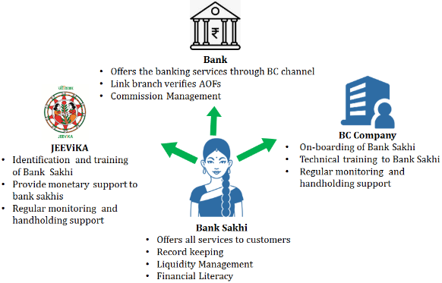

|  |  |  |
| --- | --- | --- |
| Session 1 – 7 | Prepared by BASIX Consulting and Technology Services Ltd | 13 |

**Session 1-8: What is Bank Sakhi” and what is the need of SHG members as a Bank Sakhi?**

|  |  |  |
| --- | --- | --- |
| Session 1 – 8 | Prepared by BASIX Consulting and Technology Services Ltd | 14 |

**Session 1-9: BC Model –MBGB Bank**

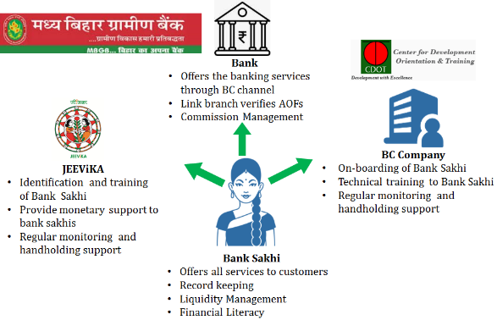

|  |  |  |
| --- | --- | --- |
| Session 1 – 9 | Prepared by BASIX Consulting and Technology Services Ltd | 15 |

**Session 1-10: Madhya Bihar Gramin Bank**

* Madhya Bihar Gramin Bank which is sponsored by **Punjab National Bank** is a Regional Rural Bank.
* As on 31.03.2017 there are **702** Branches of MBGB spread across **11 districts** of Bihar namely: Arwal, Aurangabad, Bhojpur, Buxar, Gaya, Jehanabad, Kaimur, Nalanda, Nawada, Patna and Rohtas

As on 31.03.2017

* + **Total Deposit of MBGB Rs.10392.82 Crores**
  + **Total Advances Rs.4171.46 Crores**

|  |  |  |
| --- | --- | --- |
| Session 1 – 10 | Prepared by BASIX Consulting and Technology Services Ltd | 16 |

**Session 1-11: Banks in India**

|  |  |  |
| --- | --- | --- |
| Session 1 –11 | Prepared by BASIX Consulting and Technology Services Ltd | 17 |

**Session 1-12: Public Sector bank (Examples)**

****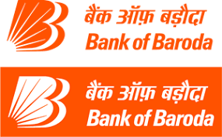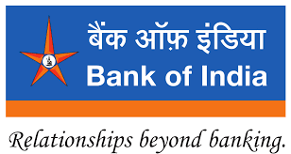

|  |  |  |
| --- | --- | --- |
| Session 1 – 12 | Prepared by BASIX Consulting and Technology Services Ltd | 18 |

**Session 1-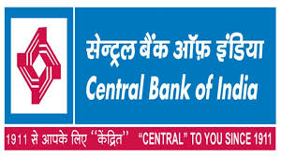 13: Private Sector Bank (Examples)**



|  |  |  |
| --- | --- | --- |
| Session 1 – 13 | Prepared by BASIX Consulting and Technology Services Ltd | 19 |

**Session 1-14: Regional Rural Bank (Examples)**



|  |  |  |
| --- | --- | --- |
| Session 1 –14 | Prepared by BASIX Consulting and Technology Services Ltd | 20 |

**Session 1-15: Main Functions of Bank**

|  |  |  |
| --- | --- | --- |
| Session 1 – 15 | Prepared by BASIX Consulting and Technology Services Ltd | 21 |

**Session 1-16: Fixed Deposit**

**Savings + Interest = Total Savings**

|  |  |  |
| --- | --- | --- |
| Session 1 – 16 | Prepared by BASIX Consulting and Technology Services Ltd | 22 |

**Session 1-17: Recurring Deposit**

**Savings + Savings +………………… Savings + Interest = Total Savings**

|  |  |  |
| --- | --- | --- |
| Session 1 – 17 | Prepared by BASIX Consulting and Technology Services Ltd | 23 |

**Session 1-18: Pension**

|  |  |  |
| --- | --- | --- |
| Session 1 –18 | Prepared by BASIX Consulting and Technology Services Ltd | 24 |

**Session 1-19: Insurance**

* House and life
* Accidental and medical
* Vehicle
* Cattle
* Crop

|  |  |  |
| --- | --- | --- |
| Session 1 – 19 | Prepared by BASIX Consulting and Technology Services Ltd | 25 |

## Facilitation Notes

1. Facilitator will first ask the participants; how many of them have bank account or done financial transactions with bank and what are the benefits of banking facilities   
   **Slide - Session 1 - 2**
2. Facilitator will wait for the answer of the participants and then with the help of  
   **Slide - Session 1 - 3** explain the benefits of banking facility

* **Savings for future:** Bank account induces saving habits. People tend to spend money on unnecessary things if money is kept at home. But if money is saved in bank account they don’t spend it on unnecessary things.
* **Security:** Money kept at the bank account remains safe and secure from theft or other natural or man-made calamities like flood, fire, rodent attack etc.
* **Government Payment:** People can receive government payment and subsidy like MGNREGA payment, gas subsidy in their bank account.
* **Send and receive money**: With help of bank people can send money to or receive money from any bank account instantly.
* **Availing financial services like insurance and pension:** Insurance products like PMJJBY and PMSBY and pension scheme; Atal Pension Yojna, APY can only be availed through a bank account.
* **Poverty reduction and economic prosperity:** As bank accounts induces saving habit and people can take credit from banks at low interest rate, it brings economic prosperity and reduces poverty.

1. Facilitator will explain to the participants that there is positive co relation between access to financial products, banking and economic prosperity. Access to financial services is also called financial inclusion.
2. “Financial Inclusion, broadly defined, refers to universal access to a wide range of financial services at a reasonable cost. These include not only banking products but also other financial services such as insurance and equity products.”
3. Facilitator will now ask participants about their experience and problems in dealing with the banks **Slide - Session 1 - 4**
4. With the help of **Slide - Session 1 - 5** facilitator will explain the problems of dealing with bank branch

* **Distance of Bank Branch**: Most of the bank branches are situated at big places and are very far from the villages. It costs both time and money to reach the bank branch. People also lose their productive hours while dealing in bank branch.
* **Overcrowding**: Most of the time braches are dealing with many customers and it causes delay in providing services to customers.
* **Cumbersome documentation:**  Illiterate and semi-literate customers find it difficult to do transactions at branch as it requires a lot of paper work.
* **Sometime rural customers** are not able to relate to the bank staff who have a typical urban mind-set.

1. Facilitator will explain the inadequate banking infrastructure in rural India and Bihar with the help of **Slide -** **Session 1 - 6**

There are only 50860 branches in rural India as on 31 March 2017. There are around 600000 villages in India. So on average a branch is serving around 12 villages. In Bihar also the scenario of banking infrastructure is not encouraging. There are only 6876 bank branches for more than 10 crore people of Bihar.

1. Also opening of bank branch is very cumbersome and expensive. Bank don’t open branches at remote places and villages as it is not economically viable for them.
2. Facilitator will explain the BC model with the help of **Slide- Session 1 - 7**

Looking at all these facts that financial inclusion of people is necessary for the economic prosperity and limited number of bank branches at rural areas; Reserve Bank of India (RBI) has introduced Business Correspondent (BC) model in 2006 to serve unbanked and poor people. RBI has allowed bank to appoint agents and provide limited banking facility to customers. These agents open their CSP at remote or unbanked locations to serve people.

* Banks can’t setup CSP centers at all locations on their own. So, they hire an agency to do that. These agencies are called Corporate Business correspondent.
* Every BC is attached with a bank branch and that bank branch is called link branch.
* BC or Business Correspondent are agents of bank and bank does not have to invest much in establishing a BC outlet or Customer Centre Point (CSP).
* Banks pay commission to these agents based on their transaction or business volume and agents provide limited number of financial services to customers. This is an entrepreneurial activity and not a job. BC or Business correspondent must invest some money in the business just like any other business and then they earn commission based on their business volume.

1. Now facilitator will ask the participants about what they understand by “Bank Sakhi” and what is the need of SHG members as a Bank Sakhi? **Slide- Session 1- 8**

*Facilitator will wait for the answers and then discuss the following points*

* When BC agent is a rural woman, she is called a “Bank Sakhi”.
* SHG members are integrated into the community (through their own SHG and village level organization) and other community member know and trust them as they are more likely to stay within the community rather than migrate for other job opportunities.
* They have experience of working with bank and other financial Inclusion interventions and are also aware about fundamentals of financial literacy.

1. Now facilitator will tell the participants about the Madhya Bihar Gramin Bank and C-DOT with help of **Slide- Session 1-9**. These Bank Sakhi would work as agent of Madhya Bihar Gramin bank. MBGB has hired C-DOT for agent management.
2. Now facilitator will tell the participants about the MBGB Bank with the help of  **Slide- Session 1-10**

Madhya Bihar Gramin Bank which is sponsored by Punjab National Bank is a Regional Rural Bank. As on 31.03.2017, there are 702 Branches of MBGB spread across 11 districts of Bihar namely: Arwal, Aurangabad, Bhojpur, Buxar, Gaya, Jehanabad, Kaimur, Nalanda, Nawada, Patna and Rohtas

**As on 31.03.2017**

Total Deposits of MBGB Rs.10392.82 Crores

Total Advances Rs.4171.46 Crores

1. Now Facilitator will explain banks and types of banks in India and its main services.
2. Facilitator will ask the participants what they understand about bank and also what are the main services of bank.
3. Facilitator will wait for the answer and then discuss the following points;

A bank is a financial institution licensed to receive deposits and make loans. Banks may also provide financial services, such as, currency exchange money transfers, issue of demand drafts, leasing out safety lockers, and collection of cheques. In addition to that banks also provide other financial products like insurance and pension schemes.

1. With the help of **Slide-Session 1 - 11** facilitator will explain the types of banks in India

*In India banks could be classified as;*

1. Facilitator will explain the example of public sector bank with the help of   
   **Slide-Session 1 - 12**

**Public Sector Bank:** Public Sector Banks (PSBs) are banks where more than 50% of the share is held by a government. There are total 21 PSBs in India. Some of the main PSBs are State bank of India, Punjab National Bank, Central Bank of India, Bank of India etc.

1. Facilitator will explain the example of private sector banks with the help of   
   **Slide-Session 1 - 13**

**Private Sector Bank:** Private Sector Banks are banks where more than 50% of the share is held by private share holder. Currently there are 21 private sector banks in India. Some of the main private sector banks are Axis Bank Limited, HDFC Bank Limited, ICICI Bank Limited, IDFC Bank Limited, Kotak Mahindra Bank Limited etc.

1. Facilitator will explain the example of Regional Rural Banks with the help of **Slide-Session 1 - 14**

**Regional Rural Bank:** Regional Rural Banks are owned by the Central Government, the State Government and the Sponsor Bank (Any commercial bank can sponsor the regional rural banks). The main purpose to establish these banks is to help rural people and provide them financial services. Some of the RRBs are Madhya Bihar Gramin Bank, Bihar Gramin Bank, Uttar Bihar Gramin Bank etc.

**Foreign Bank:** Foreign banks are banks which have been incorporated in some other countries. Some of the foreign banks are Bank of America, Hong Kong and Shanghai Banking Corporation Limited, Citibank N.A. etc.

**Local Area Bank:** Local area banks are banks which function in a particular area only. There are only three local area banks in India.

**Recently two new type of banks have been introduced by RBI**

1. Small Finance Bank (SFB)
2. Payment Banks
3. We will discuss the main functions and services offered by the bank.

Facilitator will ask the participant; do they know what are the main function/ services of the bank. Encourage participants to take part and then discuss the following.

1. Main function of the banks is taking deposit and advancing loan. Deposits could further be classified into demand and term deposits. **Slide-Session 1 - 15**

**Demand Deposits:** Demand deposits are deposit which are repayable on demand. Money can be withdrawn from account any time by issuing cheque, micro ATMs, ATM or withdrawal forms at the bank branches.

There are mainly two type of demand deposits in banks;

1. **Savings bank deposits**
2. **Current account deposits**

**Savings Bank deposits:** Savings bank account are used for small savings. Individuals as well as institutions can open savings bank account in bank. Banks pay interest on deposits also. Banks provide cheque book and debit card to account holder. Customer can deposit money in and withdraw money from their account. In addition to that they could also transfer money from their account to any other bank account. Most of the banks also provide passbook to the customers.

As these account are opened to encourage saving habits so bank put a limit on withdrawal from accounts and if the limit is crossed then bank may charge fee from their customers also for withdrawals.

**Current account deposits:** Current account is opened for business purpose only. Individuals and institution both can open current account. Banks don’t provide any interest on current account deposits. There is no limit on number of withdrawals or deposits in the current account. Bank issue cheque book to current account. Generally, bank don’t provide passbook in current account and only provide monthly statement to account holders.

**Time Deposit:** Time deposits are deposits which are repayable on maturity dates only. It’s an interest-bearing bank deposit that has a specified date of maturity. There are two types of time deposits;

1. **Fixed deposits** and
2. **Recurring deposits**
3. With help of **Slide-Session 1 - 16** explain Fixed deposit

**Fixed Deposit**: Fixed deposit are deposits where a customer deposit amount for a fixed tenure and at an agreed rate of interest. The rate of interest paid by the banks is generally higher than savings bank account. The rate of interest differs from bank to bank and depends on the tenure of deposit. At present bank accept fixed deposit for the period from 7 days to maximum 10 years. Though customers can not withdraw money from fixed deposit account like savings bank account but if customer wants to withdraw money before the maturity date, banks generally allow it.

1. With help of **Slide-Session 1 - 17** explain Recurring deposit

**Recurring deposits:** Recurring deposit are deposit where a fixed amount is deposited in account in regular interval for a fixed period. The rate of interest is same as of fixed deposit bank account. The only difference between a fixed deposit and recurring deposit is that in recurring deposit money is deposited at regular interval and in fixed deposit entire amount is deposited at one go.

1. **Hybrid or Flexi deposit:** Now some banks are offering hybrid or flexi deposits, which is a combination of demand deposit and time deposit.
2. **Loan:** Loans are the main source of income for the banks. Banks take deposit from customers and give this money to other customers as loan. Bank earn interest on loan. Loan can be of various types such as personal loan and business loan. Education loan, home loan are some of the personal loan. Banks provide loans for business and agriculture purposes.
3. **Other Financial Products offered by the bank**

**Pension:** Pension is a long-term savings product that provides monthly income after certain age. Government organizations and some large companies usually offer a pension to their employees. Generally in a pension plan, both employee and employer contribute to the pension fund while employee is working. Pension money is paid monthly to employee after they reach retirement age till death of the employee. Even after death of the employee their spouse or dependent get the monthly pension. Now new pension plans have been introduced and any person can subscribe to these plans. **Slide-Session 1 - Slide 18**

**Insurance:** Insurance is a means of protection from financial loss. It’s a risk mitigating financial product. In case of any loss whether loss to property or life the insurance company pay money to customer. Customer also pays some amount to insurance company to buy this protection; which is called premium. Insurance can be of various types such as life insurance, accidental insurance, vehicle insurance, house insurance etc. **Slide-Session 1 - 19**

# Session 2: Services offered through BC agent

|  |  |  |
| --- | --- | --- |
| Overview |  | This session helps participants to understand the product and services offered through kiosk banking / CSP. |
| Session Objectives |  | By the end of this session participants will be able to:   * Savings account and its benefits * Different types of time deposits * CICO: Cash deposit and withdrawal and other services * Insurance * Pradhan Mantri Suraksha Bima Yojana * Pradhan Mantri Jeevan Jyoti Bima Yojana * Pension Atal Pension Yojana |
| Duration |  | 120 min |
| Methodology and Steps |  | **Presentation and Group Exercise**  Step 1: Facilitator will explain the main feature of savings bank account of MBGB (20 minutes)  Step 2: Savings account and its feature (20 minutes)  Step 3: Different types of time deposits (20 minutes)  Step 4: CICO: Cash deposit and withdrawal and other services (20 minutes)  Step 5: Insurance (40 minutes)   1. Pradhan Mantri Suraksha Bima Yojana 2. Pradhan Mantri Jeevan Jyoti Bima Yojana 3. Pension Atal Pension Yojana |
| Resources |  | * PowerPoint presentation * Videos * Hand out: Product and service details” * Hand out: Atal Pension contribution chart |
| Trainers’ Preparation |  | Trainers should do the following before starting the session:   * Prepare required presentation, * Keep ready Videos * Prepare sufficient copies of Handouts for distribution |

## Presentations

**Slides**

**Session 2 - 1: Services through BC agent**

* Savings account and its benefits
* Different types of time deposits
* CICO: Cash deposit and withdrawal and other services
* Insurance
* Pension

|  |  |  |
| --- | --- | --- |
| Session 2 - 1 | Prepared by BASIX Consulting and Technology Services Ltd | 27 |

**Session 2 - 2: Account Opening Form (1/4)**

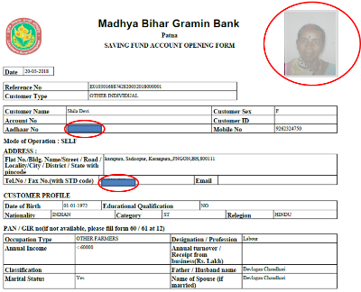

|  |  |  |
| --- | --- | --- |
| Session 2 - 2 | Prepared by BASIX Consulting and Technology Services Ltd | 28 |

**Session 2 - 3: Account Opening Form (2/4)**

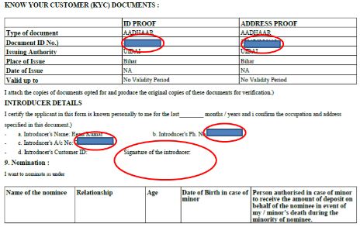

|  |  |  |
| --- | --- | --- |
| Session 2 - 3 | Prepared by BASIX Consulting and Technology Services Ltd | 29 |

**Session 2 - 4: Account Opening Form (3/4)**

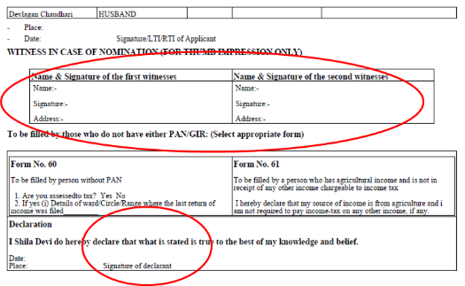

|  |  |  |
| --- | --- | --- |
| Session 2 - 4 | Prepared by BASIX Consulting and Technology Services Ltd | 30 |

**Session 2 - 5: Account Opening Form (4/4)**

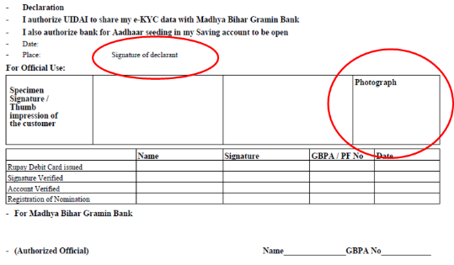

|  |  |  |
| --- | --- | --- |
| Session 2 -5 | Prepared by BASIX Consulting and Technology Services Ltd | 31 |

**Session 2 - 6: Exercise**

**Which type of deposit account is suitable for Seema and Rita?**

Seema is farmer and lives in a village. She does not have a regular income and gets income only during the harvest season. She is saving money for her child education. Her daughter is studying at 10th and will be in college in next 2 years.

Rita is a labourer and gets her income on daily basis. She wants to save money to build house as her present house is not in good shape. She is planning to build her house in 5 years.

|  |  |  |
| --- | --- | --- |
| Session 2 - 6 | Prepared by BASIX Consulting and Technology Services Ltd | 32 |

**Session 2 - 7: Pradhan Mantri Suraksha Bima Yojana- Enrolment Form**

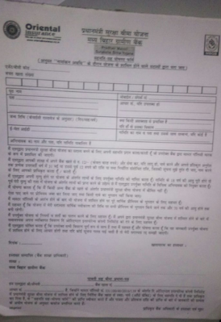

|  |  |  |
| --- | --- | --- |
| Session 2 - 7 | Prepared by BASIX Consulting and Technology Services Ltd | 33 |

**Session 2 - 8: Pradhan Mantri Jeevan Jyoti Bima Yojana- Enrolment Form**

https://www.licindia.in/getattachment/Products/Pradhan-Mantri-Jeevan-Jyoti-Bima-Yojana-(PMJJBY)/pop_00022/Consent_Form_3-PMJJBY.pdf.aspx

|  |  |  |
| --- | --- | --- |
| Session 2 - 8 | Prepared by BASIX Consulting and Technology Services Ltd | 34 |

**Session 2 - 9: Atal Pension Yojana- Enrolment Form**

http://www.mbgbpatna.com/bc-agents-data/atal-pension-registration.pdf

|  |  |  |
| --- | --- | --- |
| Session 2 - 9 | Prepared by BASIX Consulting and Technology Services Ltd | 35 |

**Session 2 - 10: Atal Pension Yojana Contribution Chart**

https://www.csb.co.in/pdf/apy%20chart.pdf

|  |  |  |
| --- | --- | --- |
| Session 2 - 10 | Prepared by BASIX Consulting and Technology Services Ltd | 36 |

## Facilitation Notes

1. Facilitator will explain the main feature of savings bank account of MBGB

**Savings bank account**: MBGB offers two type of Saving bank account to its customer through CSP point.

1. BSBDA/ PMJDY/ Jan Dhan account- Can be opened with zero balance
2. Normal Savings bank Account- Can be opened from Rs.500 at rural areas and Rs.1000 in urban areas
3. Only individual accounts can be opened at agent location. Joint accounts and accounts of minor (less than 10 years) can’t be opened at agent location.
4. Minor who are 10 years and above can also open bank account at CSP point.
5. Documents required for account opening- Passport size photographs of customer (3) and Aadhaar card.
6. Accounts are opened through e-KYC, however account numbers are not generated instantly. Accounts get opened only after submission of filled account opening form with customer’s signature and KYC documents at link branch by the bank sakhi.
7. Generally, accounts opened at CSP can be accessed through agent outlet only, however, accounts opened at MBGB Kiosk can be operated through MBGB bank branch also
8. Customer are provided passbook by bank only and it can be updated at bank branch only
9. Customer could apply for debit/ATM card and cheque book in the branch
10. Seeding of mobile number could also be done through bank branch.
11. Facilitator will show a filled savings bank form and explain it to participants with help of **Slides from Session 2 - 2 to Session 2 - 5. (10 Minutes)**
12. **Fixed deposit**: Customers can open fixed deposit account at MBGB CSP. These accounts are opened through e-KYC process only.

* FD limit – Rs. 1,000 to Rs. 50,000
* Tenure – min. 7 days – max. 10 years
* Interest paid on Fixed deposit vary from time to time and it depends on tenure of the deposit also.
* Senior Citizen; people who are 60 years and above get some extra interest on deposits.
* Customer would get the TDR receipt from bank branch only.
* Banks also deduct TDS on interest earning on fixed deposit. If in a financial year, that is from 1st April to 31st March interest earned in time deposit is more than the limit prescribed by the Income Tax Department then bank deduct TDS from the interest amount.
* Customer can submit 15G (Below 60 years) or 15H (above 60 years) forms to prevent bank from deducting the TDS.

1. **Recurring Deposit**: Recurring deposit or RD is a type of time deposit where a fixed amount is deposited in account at fixed intervals. The only difference between a FD and RD is that in FD total amount is invested at one go and in RD a fixed amount is deposited at fixed interval. The rate of interest and tenure is similar to fixed deposit schemes.

* RD limit – Rs. 100 to Rs. 5,000
* Tenure – min. 6 months – max 120 months
* Interest paid on Fixed deposit vary from time to time and it depends on tenure of the deposit also
* Customer will get the RD passbook from Bank Branch only.

1. **Case**

* Facilitator should narrate following situations and ask participants about the type of deposit account suitable for these customers with help of **Slide -** **Session 2 - 6**
* Seema is farmer and lives in a village. She does not have a regular income and gets income only during the harvest season. She is saving money for her child education. Her daughter is studying at 10th and will be in college in next 2 years.
* Rita is laborer and gets his income on daily basis. She wants to save money to build house as her present house is not in good shape. She is planning to build her house in 5 years.
* *Answer: Seema should open a fixed deposit and Rita should open a RD account.*

1. **Cash In and Cash Out (CICO) and other Transactions**

**Cash deposit and withdrawal**: BC or agent provide cash in and cash out facility to customer.

* No cash out or cash in allowed for customer of Punjab National Bank.
* Customer who have bank account at some other bank can also deposit and withdraw money from CSP point through AePS or cards.
* Currently cash deposit through AePS in other banks is not allowed.
* Cash deposit can be done in MBGB bank account through account number also.
* Per day limit for withdrawal is Rs.10,000 per bank account
* Per day limit for deposit is Rs. 25,000 per bank account

1. **Fund transfer**: Bank Sakhi also provide fund transfer facility to customers.

* Customers of MBGB can transfer money from their bank account to any other bank account.
* Cash transfer is not allowed

1. Aadhaar seeding can’t be done through CSP. Bank Sakhi can collect photo copy of Aadhaar card and passbook from customer and submit it at the Link Branch.
2. **Loan**

* Loan can’t be sanctioned from a CSP.
* Loan can only be appraised and recommended by a bank sakhi
* The maximum amount up to which loan can be appraised is Rs.15000

1. Now facilitator will discuss about two insurances product PMJJBY and PMSBY. Facilitator will show video on Prime Minister Suraksha Bima Yojna and discuss the following

* PMSBY was launched by government of India and it’s an accidental insurance policy.
* In case of accidental death a nominee/legal heir will get Rs. 2 lac rupee and in case of accident the insurer will get from Rs. 1 to Rs. 2 lac rupee as per the disability.
* Any death or disability (as defined under PMSBY) due to natural calamities such as earthquake, flood are also covered under PMSBY. Natural death and suicidal deaths are not covered under this scheme.
* **Eligibility -**Any person between age group of 18 to 70 having a bank account
* **Premium-** Yearly Rs. 12 and it would be deducted from bank account only
* **Benefit-** The table below gives details of policy benefits

|  |  |
| --- | --- |
| Benefit | Sum Insured |
| Death | Rs. 2 Lakh |
| Total irrecoverable loss of both eyes or loss of use of both hands or feet or loss of sight of one eye and loss of hand or foot | Rs. 2 Lakh |
| Total and irrecoverable loss of one eye or loss of use of one hand or foot | Rs. 1 lakh |

* One can get PMSBY through one bank account only even if they have multiple bank account.
* All family members who have bank account and are between 18 to 70 can enroll themselves in this scheme.

1. Facilitator will distribute the PMSBY application from and explain the participants how to fill it with help of **Slide - Session 2 - 7**
2. **Pradhan Mantri Jeevan Jyoti Bima Yojana** (PMJJBY) is a life insurance scheme. Facilitator will show video of PMSBY and explain the following

* All kind of death including natural death is covered under this insurance scheme.
* Premium- Total yearly premium of the insurance is Rs.330 and it is renewable from year to year. Premium will be deducted from the account of the insurer only. Nomination is must in this scheme.
* **Eligibility -**Any person between age group of 18 to 50 having a bank account can join this scheme. Once a person joins the scheme he or she can avail this facility till the age of 55.
* **Premium-**Yearly Rs. 330 and it would be deducted from bank account only
* **Benefit -**Nominee will get Rs. 2 lac in case of death of insured person
* One can get PMJJBY through one bank account only even if they have multiple bank account.
* All family members who have bank account and are between 18 to 50 can enroll themselves in this scheme.

1. Customers can enroll themselves for both the insurance schemes if they fulfil the eligibility criteria and they will get benefit of both the schemes in case of accidental death. The nominee/family member will get Rs. 4 lacs.
2. We have discussed about pension in the previous session. Pension is long term saving scheme for old age. Generally government agencies and big private institution provide pension facility to their employee or staff.
3. Employee and employer both contribute to the pension fund and after the retirement employee get monthly pension for their entire life time. Even after death of the employee the dependent get the benefit of the pension.
4. Government of India has introduced a new pension scheme which is called Atal Pension Yojna.
5. Facilitator will show video of APY and explain the following

* Any person who is between18 to 40 can subscribe it
* House wife, daily wage earner, laborer, farmer, salaried class all kind of people can subscribe this pension scheme.
* The subscriber of this pension scheme need a savings bank account
* The subscriber pay contribution to the pension fund till age of 60 and contribution is directly deducted from customer account. Subscribers can deposit contribution monthly, quarterly or half yearly as per their choice and convenience.
* After 60 years subscriber get monthly pension of 1000, 2000, 3000, 4000, or 5000 as per their contribution amount. After the death of the pensioner spouse of the pensioner get the monthly pension for the entire life time. In case of death of both pensioner and their spouse, nominee of the pensioner get a lump sum amount also.
* Nomination is must in this scheme.
* **Eligibility -**Any person between age group of 18 to 40 having a bank account

1. **Contribution-**Contribution can be deposited monthly, quarterly or half yearly. The contribution amount depends on the age and monthly pension. It starts from as low as Rs. 42 monthly. **Show Slide - Session 2 - 10**
2. **Benefit -**After 60 years subscriber get monthly pension of 1000, 2000, 3000, 4000, or 5000 as per their contribution amount
3. One can get APY through one bank account only even if they have multiple bank account.
4. All family members can avail this scheme.
5. Bank Sakhi will get the form of APY filled from the customer and submit it in the bank branch
6. Now facilitator will distribute the APY form and show participant how to fill it with help of **Slide - Session 2 - 8.**

# Session 3: Know Your Devices

|  |  |  |
| --- | --- | --- |
| Overview |  | This session helps participants to understand the basics of the devices used in conducting BC operations and how to maintain these devices. |
| Session Objectives |  | By the end of this session participants will be able to:   * Understand the basics of devices required for BC operations * Maintenance of the devices |
| Duration |  | 60 min |
| Methodology and Steps |  | **Presentation and Demonstration**  Step 1: Types of devices (10 minutes)  Step 2: Basic understanding of these devices (10 minutes)  Step 3: Services offered (20 minutes)  Step 3: Maintenance (20 minutes) |
| Resources |  | * PowerPoint presentation titled “Know your device”. It has 12 slides” |
| Trainers’ Preparation |  | Trainers should do the following before starting the session:   * Prepare required presentation |

## Presentations

**Slides**

**Session 3 - 1: Know your devices**

* Types of devices
* Basic understanding of these devices
* Services offered
* Maintenance

|  |  |  |
| --- | --- | --- |
| Session 3 - 1 | Prepared by BASIX Consulting and Technology Services Ltd | 38 |

**Session 3 - 2: What kind of devices are required for conducting BC operations?**

|  |  |  |
| --- | --- | --- |
| Session 3 - 2 | Prepared by BASIX Consulting and Technology Services Ltd | 39 |

**Session 3 - 3: Devices for Conducting BC Operations (1/2)**

For BC operations you would require the devices shown here. You might not require all the devices. It will differ from bank to bank.

* Laptop
* microATM
* Biometric scanning device
* mPOS (card reader)

|  |  |  |
| --- | --- | --- |
| Session 3 - 3 | Prepared by BASIX Consulting and Technology Services Ltd | 40 |

**Session 3 - 4: What is Laptop?**

Laptop is a smaller version of a desktop computer that contains the hard drive, disk drive, monitor, wireless modem, keyboard, speakers, web camera and mouse in a single unit. It is portable.

|  |  |  |
| --- | --- | --- |
| Session 3 - 4 | Prepared by BASIX Consulting and Technology Services Ltd | 41 |

**Session 3 - 5: Usage of Laptop for BC Operations**

For conducting BC operations through laptop, a software needs to be installed. This will be installed by the service provider

Following services will be available through laptop:

* Account opening
* Transactions
* Non-financial services such as ticket booking, e-governance services etc.

Additional devices to be used along with laptop:

* Biometric capturing device- For Aadhaar authentication during account opening and transactions
* microATM- For card swipe transactions
* Printer- For printout of forms and receipts
* Internet connection is required for conducting BC operations as the transactions are always online and real time. For internet connection you can get wi-fi connection or internet dongle of any telecom service provider or can use mobile internet wi-fi hotspot.

|  |  |  |
| --- | --- | --- |
| Session 3 - 5 | Prepared by BASIX Consulting and Technology Services Ltd | 42 |

**Session 3 - 6: Keep your Laptop Safe**

**Do’s**

* Remove the charger whenever the laptop shows 90-100% charged.
* Always use a proper size of laptop bag.
* If using Wi-Fi, make sure that your antivirus program is running and updated.
* Try to keep your laptop away from any kind of dust or dirt.
* Clean keyboard with tooth brush or if there is lot of dust
* Make habit to shut down the laptop whenever it’s in idle mode.
* In case of any hardware issue in the laptop get it repaired only from authorized vendors
* In case of any software issue, contact the corporate BC or the bank
* Keep your laptop away from the kids.

**Don'ts**

* Don’t put the charger on power for long, it might result in battery failure and reduce the life span of battery.
* Don’t keep your laptop near to any gadget which emits heat or radiations.
* Don’t keep your laptop on rough or unstable surface. Always try to keep it on hard surface (usually table)
* Don’t keep any hard or pointed thing near laptop screen, it might result in scratches.
* Don’t keep food or drinks near laptop as they can result in device failure.

|  |  |  |
| --- | --- | --- |
| Session 3 - 6 | Prepared by BASIX Consulting and Technology Services Ltd | 43 |

**Session 3 - 7: What is Biometric Scanning Device?**

* This device scans and capture finger print of a person. It helps in authentication of a person’s identity.
* Costs around Rs. 4000-5000
* Connected to the laptop through USB cable

**Fingerprint Scanning Tips**

It is important to capture the highest quality fingerprint image possible because this image is used as a comparison during verification. If the images do not match, the user is not allowed access. To ensure proper image:

* Lay the finger flat on the screen. Apply enough pressure to generate a clear image.
* Center the core of the image on the fingerprint scanner.
* Do capture the index finger first for the best quality image. If it becomes necessary to capture alternate fingers, use the middle or ring fingers next. Avoid little fingers and thumbs because they generally do not provide a high quality image.
* Ensure that the finger is clean and not oily as the scanner will not be able to capture clear image

|  |  |  |
| --- | --- | --- |
| Session 3 - 7 | Prepared by BASIX Consulting and Technology Services Ltd | 44 |

**Session 3 - 8: microATM (1/3**

* Micro ATM is a mini version of an ATM. Micro ATMs are like modified point of sales terminals. This terminal can connect to banking network via internet to perform banking transactions.
* It is portable and can be carried anywhere
* Facilitates biometric enabled secured transactions
* MicroATM supports basic transaction types such as:
* Cash Deposit
* Cash Withdrawal
* Fund Transfer
* Balance Enquiry
* There are many variants of microATM in the market.
* The process of conducting transactions and services offered depends upon the type of microATM
* MicroATMs are provided by service provider, you do not have to purchase it from open market

|  |  |  |
| --- | --- | --- |
| Session 3 - 8 | Prepared by BASIX Consulting and Technology Services Ltd | 45 |

**Session 3 - 9: microATM (2/3)**

This microATM can work on both mobile data and Wifi. Following services can be offered through this:

* eKYC account opening
* Transactions- AePS

|  |  |  |
| --- | --- | --- |
| Session 3 - 9 | Prepared by BASIX Consulting and Technology Services Ltd | 46 |

**Session 3 - 10: microATM (3/3)**

* This microATM has a SIM card slot and work through internet
* It can be used only for transactions- deposit, withdrawal, balance enquiry, fund transfer etc.

|  |  |  |
| --- | --- | --- |
| Session 3 - 10 | Prepared by BASIX Consulting and Technology Services Ltd | 47 |

**Session 3 - 11: Keep microATM safe**

* Daily charge the battery of microATM
* Keep microATM away from any dirt or dust
* In case of any hardware and software issue in the device, contact the bank or corporate BC. Do not give the device to any local vendor for repairing
* Do not man-handle the device or press multiple buttons at the same time
* Keep the device safe, as this needs to be returned to the service provider if you discontinue bank sakhi work

|  |  |  |
| --- | --- | --- |
| Session 3 - 11 | Prepared by BASIX Consulting and Technology Services Ltd | 48 |

**Session 3 - 12: What is mPOS ?**

* mPOS stands for Mobile POS or Mobile Point of Sale device. It’s a handheld device for card swipe transactions.
* It can get linked to any android device through Bluetooth and software for operating mPOS is installed in the android device such as smartphone or tablet.
* Connecting android device should have an active internet connection or access to wi-fi at the time of performing card swipe transactions through mPOS

|  |  |  |
| --- | --- | --- |
| Session 3 - 12 | Prepared by BASIX Consulting and Technology Services Ltd | 49 |

## Facilitation Notes

1. Ask the participants, what all devices are required for conducting BC operations. After receiving responses from the participants, display S**lide: Session 3 - 3** to tell the participants that there are 4 main devices that they would have to use for conducting BC operations and usage of these devices would differ from bank to bank. They might not be required to use all the devices.
2. Laptop
3. microATM
4. Biometric scanning device
5. mPOS
6. Ask the participants how many of them have seen any of the above devices and used any of them in the past. Listen to the responses of the participants to gauge their understanding about the devices (5mins.)
7. Tell the participants that two main devices required for conducting BC operations are Laptop and microATM, rest all the devices such as biometric scanning device and mPOS will be used in combination with Laptop and microATM.
8. Display slide#4 to explain the participants what Laptop means and what are some of the basic parts of laptop.

**What is Laptop?**

Laptop is a smaller version of a desktop computer that contains the hard drive, disk drive, monitor, wireless modem, keyboard, speakers, web camera and mouse in a single unit. It is portable and can be easily carried from one place to another for working. Bank Sakhis can carry it to the SHG meetings etc. for conducting BC operations.

**Using your own laptop, explain basic parts of laptop. The basic parts of laptop are**

|  |  |
| --- | --- |
| **LCD Screen** | It is the display of the laptop where you can see the text and image or any work being done on the computer. |
| Keyboard | For typing information |
| Touch Pad mouse | It’s a pointing device for moving the cursor on the screen. The touch of your finger on this pad moves the mouse on the computer. The two smaller rectangles below the square pad are the left and right click buttons. |
| Power button | The circular button located above the keyboard on the far right that contains a picture of a circle with a vertical bar. This button starts up and shuts down your laptop by pressing it. |
| DVD/CD-ROM drive | This is located on the side of your laptop. Pressing the small button will open and close the door so that you can insert CD’s and DVD’s to be used. |
| USB Port/Ports | This port or ports are located on the side of your laptop near the hinge. They are used to connect USB media such as a flash drive, USB mouse, digital camera, or biometric scanning device |
| AC/DC Power Adapter | It is used for charging the laptop |
| Battery | It’s a secondary source of power for laptop and keeps the laptop running when it is unplugged from the electricity current. |

**Cost of Laptop**: Laptop for conducting BC operations can come in the range of Rs. 25,000-35,000

1. Use **Slide - Session 3 - 5** to explain the usage of Laptop in BC operations.
2. Use **Side - Session 3 - 6** explain how bank sakhis can keep their laptops safe
3. Use **Slide-Session 3 - 7** to explain biometric capturing device and tips for effective fingerprint scanning
4. Use **Slides from Session 3 - 8 to Session 3 - 10** for explaining what is microATM, what services can be provided through microATM and different variants of microATM
5. Use **Slide-Session 3 - 11** for explaining tips to maintain microATM
6. Use **Slide Session 3 - 12** to explain the concept of mPOS
7. Close the session and move to next session of “Regulatory Compliance

# Session 4: Regulatory compliance

|  |  |  |
| --- | --- | --- |
| Overview |  | This session helps participants to understand the basic concept of KYC policy and AML. |
| Session Objectives |  | By the end of this session participants will be able to:   * RBI KYC policy * Concept of e-KYC and its advantages * Basic concept of Anti Money Laundering (AML) |
| Duration |  | 30 min |
| Methodology and Steps |  | **Lecture, discussion and Group Exercise**  Step 1: Lecture (10 minutes)  Step 2: Discussion (10 minutes)  Step 3: Group Exercise (10 minutes) |
| Resources |  |  |
| Trainers’ Preparation |  | Trainers should do the following before starting the session:   * Prepare for topic * Markers and white board * Chats * Exercise related material |

## Facilitation Notes

1. Facilitator will narrate the following the situation

*Seema is a Bank Sakhi working in a village. One day when Seema was at her outlet attending customers, a person came and told Seema that he need to send money to his son immediately. Seema asked her Aadhaar number and bank name. The customer told her that he does not want to use his own account for doing transactions.*

*Then the customer request her to send the money to his son account through her own account and he would pay her in cash and the charges in cash.*

***What should Seema do?***

1. Facilitator should wait for the participants answer and then discuss the following

Bank Sakhi should not use her personal account to do transaction for her customers. This could be case of money laundering where people want to hide the real source of money.

1. To prevent fraud and money laundering RBI has issued **KYC** or “Know Your Customer “guidelines.
2. As per the guidelines RBI has mandated that before opening of account customers identity and address should be established.
3. As per RBI, customers at their option, shall submit one of the six OVDs for proof of identity and proof of address.

**Officially valid document” (OVD) means;**

1. Passport,
2. Driving licence,
3. Permanent Account Number (PAN) Card,
4. Voter's Identity Card issued by the Election Commission of India,
5. Job card issued by NREGA duly signed by an officer of the State Government,
6. Aadhaar Card.
7. Now e-KYC is also used for KYC verification. In e-KYC customer Aadhaar information like photograph, demographic details, residential address are electronically shared with banks. There are two types of e-KYC. One is OTP based e-KYC and another is biometric based e-KYC.
8. In biometric based e-KYC customer gives his/her biometrics information to the bank and UIDAI shares customers’ identity and address proof with the bank. This process is very secure and account can be opened without any paper work.
9. In addition to KYC policy and guidelines; any suspicious transaction like terrorist financing, drug financing, illegal transaction should be reported to the bank.
10. These guideline are called AML or Anti Money laundering guidelines and are issued by government of India.

# Day - 2

# Session 5: Payment systems and liquidity management

|  |  |  |
| --- | --- | --- |
| Overview |  | This session helps participants to understand different payment options and also their process flow. The session also give a view of settlement account and liquidity management. |
| Session Objectives |  | By the end of this session participants will be able to:   * On Us and Off Us transactions * Different payment options and process flow * AePS * Card Payment * Concept of settlement account * Effective float management techniques |
| Duration |  | 105 min |
| Methodology and Steps |  | **Presentation and Group Exercise**  Step 1: Payment option (45 minutes)  Provides the payment options and their architect.  Step 2: Concept of settlement account and liquidity management  (60 minutes)  Provides information about settlement account and how to maintain liquidity. |
| Resources |  | PowerPoint presentation titled ‘Payment systems and float management’ |
| Trainers’ Preparation |  | Trainers should do the following before starting the session:   * Prepare required presentation |

## Presentations

**Slides**

**Session 5 - 1: Payment systems and float management**

* Different payment options and process flow
* AePS
* Card
* Concept of settlement account
* Effective float management techniques

|  |  |  |
| --- | --- | --- |
| Session 5 - 1 | Prepared by BASIX Consulting and Technology Services Ltd | 51 |

**Session 5 - 2: Exercise**

**For each of the cases given below, determine the type of transaction- Off Us or On Us**

* Samir is a farmer who lives in a village and has no bank account. His daughter is studying in a big town. She needs some money for her studies. Samir goes to a Bank Sakhi of A bank to deposit money at her daughter account which is in B bank.
* Seema is a house wife and has account at bank A. She regularly saves money in her bank account through Bank Sakhi of bank A.
* Aajad is a small business man and has a bank account at bank A. He need some money and went to Bank Sakhi of bank B to withdraw money.

|  |  |  |
| --- | --- | --- |
| Session 5 -2 | Prepared by BASIX Consulting and Technology Services Ltd | 52 |

**Session 5 - 3: Process flow AEPS (On Us Transaction)**

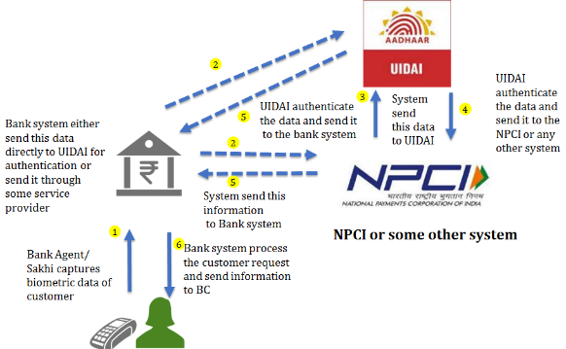

|  |  |  |
| --- | --- | --- |
| Session 5 - 3 | Prepared by BASIX Consulting and Technology Services Ltd | 53 |

**Session 5 - 4: Process flow AEPS (Off Us Transaction)**

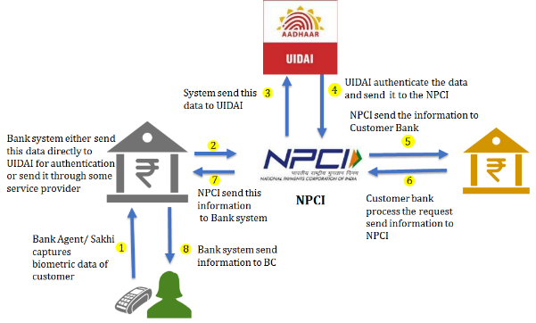

|  |  |  |
| --- | --- | --- |
| Session 5 - 4 | Prepared by BASIX Consulting and Technology Services Ltd | 54 |

**Session 5 - 5: Process flow Card Transaction (On Us Transaction)**

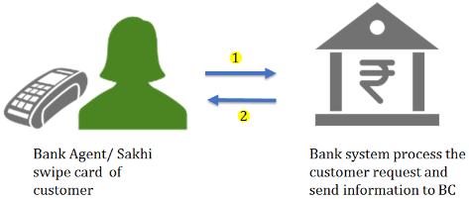

|  |  |  |
| --- | --- | --- |
| Session 5 - 5 | Prepared by BASIX Consulting and Technology Services Ltd | 55 |

**Session 5 - 6: Process flow Card Transaction (Off Us Transaction)**

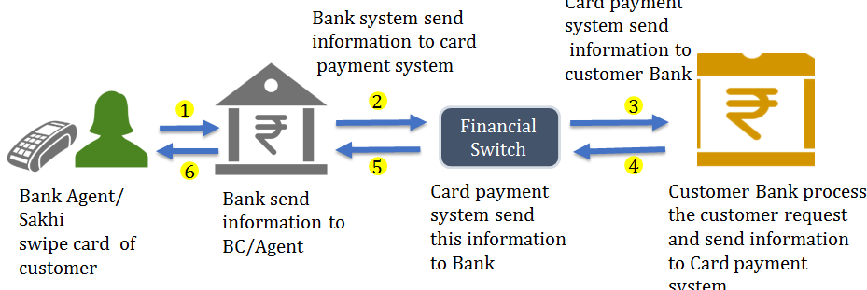

|  |  |  |
| --- | --- | --- |
| Session 5 - 6 | Prepared by BASIX Consulting and Technology Services Ltd | 56 |

**Session 5 - 7: Liquidity Management and settlement**

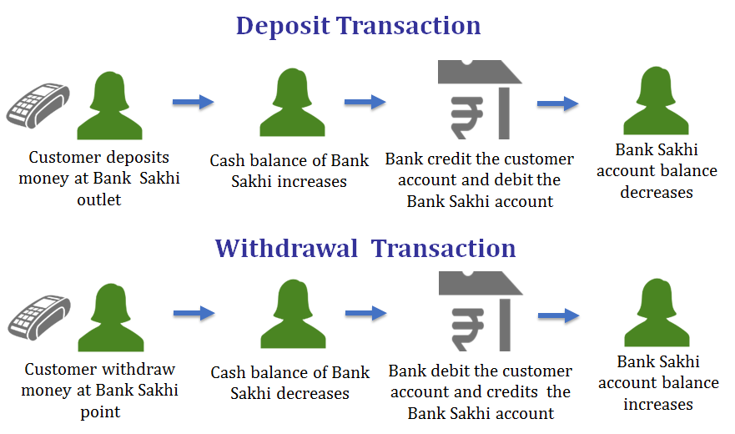

|  |  |  |
| --- | --- | --- |
| Session 5 - 7 | Prepared by BASIX Consulting and Technology Services Ltd | 57 |

**Session 5 - 8: Exercise**

**Calculate closing cash in hand and digital cash balance with the information given below**

* Opening Cash Balance 10,000
* Opening digital cash Balance 2000

|  |  |
| --- | --- |
| **Type of Transaction** | **Amount in Rs.** |
| Deposit | 500 |
| Withdrawal | 2000 |
| Transfer(Account to Account) | 8000 |
| Deposit | 3500 |

|  |  |  |
| --- | --- | --- |
| Session 5 – 8 | Prepared by BASIX Consulting and Technology Services Ltd | 58 |

## Facilitation Notes

1. Facilitator will explain the type of transaction. There are two types of transaction.
2. **On Us Transaction**
3. **Off Us Transaction**
4. **On Us Transaction**: An intra-bank (ON-US) transaction where a transaction has effects only in accounts within one and same bank and does not necessitate an interbank settlement it’s called On Us transaction. For example, if a customer of MBGB bank uses MBGB kiosk for depositing or withdrawing money from MBGB account, then it will be an On Us transaction.
5. **Off Us Transaction:** An inter-bank (OFF-US) transaction is one where there is movement of funds from one bank to another bank or have effect on two banks. If customer of some other bank uses MBGB kiosk to deposit or withdraw money, then it would be an Off Us transaction. If a customer uses MBGB kiosk to transfer fund to bank account of some other bank, then it also would be Off Us Transaction
6. Now facilitator will give the following scenario to participants and ask the participants to determine the type of transaction (**Use Slide Session 5 - 2**)

Samir is a farmer who lives in a village and has no bank account. His daughter is studying in a big town. She needs some money for her studies. Samir goes to a Bank Sakhi of **A** bank to deposit money at her daughter account which is in **B** bank.

**Answer off Us**

Seema is a house wife and has account at bank **A**. She regularly saves money in her bank account through Bank Sakhi of bank **A**.

**Answer On Us**

Aajad is a small business man and has a bank account at bank **A**. He need some money and went to Bank Sakhi of bank **B** to withdraw money.

**Answer off US**

1. Now facilitator will explain the two payment option available for doing transaction
2. **AePS:** Aadhaar Enabled Payment System
3. **Card Transaction**
4. **AEPS:** Aadhaar Enabled Payment System (AEPS) is developed by National Payment Corporation of India, NPCI which allows online interoperable financial transaction through the Business Correspondent (BC)/Bank Mitra of any bank using the Aadhaar authentication. In this payment system customer finger print is scanned through biometric device and sent to UIDAI for authentication. Customer must seed or add their bank account with their Aadhaar number to avail this facility. Customer can deposit, withdraw, transfer money and check balance through this facility.
5. With the help of **Slide - Session 5 - 3** facilitator will explain the process of AePS On Us transaction

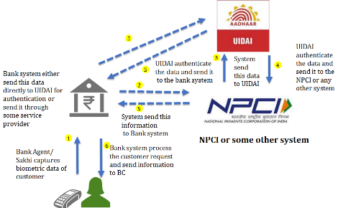

**Step 1**: BC captures the biometric data of customer and key in the transaction details

**Step 2**: BC system send this data to Bank system

**Step 3:** Bank system send the biometric data to UIDAI either directly or through some Authentication Service Agency (ASA). UIDAI authenticated the data and send it to either bank or ASA agency.

**Step4:** ASA send this data to bank system

**Step5**: Bank then process the customer request and sent the information to BC

**Step6:** BC receive the information and do the necessary formalities

1. Similarly, facilitator will explain the AePS Off Us transactions with the help of   
   **Slide- Session 5 - 4**

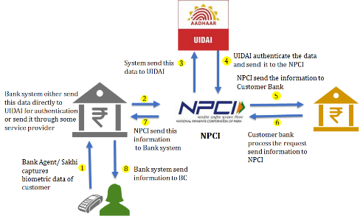

**Step 1:** BC captures the biometric data of customer and key in the transaction details and BC system send this data to Bank system

**Step 2 and 3:** Bank system send the biometric data to UIDAI either directly or through some Authentication Service Agency (ASA) like NPCI.

**Step 4:** UIDAI authenticated the data and send it to either bank or ASA agency or NPCI.

**Step 5:** NPCI sends customer transaction request data to customer bank

**Step 6:** Customer bank process the request and send the information to NPCI

**Step 7**: NPCI send the response from customer bank to bank system

**Step 8:** Bank sent the response to BC. BC receive the information and do the necessary formalities

1. Customer can do financial transaction through ATM or debit card also. Customer can deposit, withdraw, transfer money and check balance through cards. RuPay, Visa, MasterCard are some of the example of card.
2. Facilitator will explain the process of On Us Card transaction with the help of   
   **Slide – Session 5 - 5**

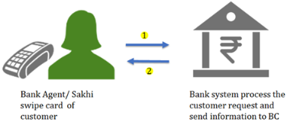

**Step 1:** BC swipe the card and key in the customer request and request is sent to bank System

**Step 2:** Bank system process the transaction and send information to BC. BC receive the information and do the necessary formalities

1. Facilitator will explain the process of Off Us Card transaction with the help of   
   **Slide Session 5 - 6**

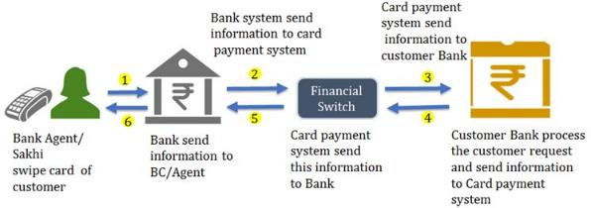

**Step1:** BC swipe the card and key in the customer request and request is sent to bank system

**Step 2:** Bank system send this information to financial switch

**Step 3:** Financial switch then sends this information to customer bank

**Step 4:** Customer Bank process the customer request and sends the response to financial switch

**Step 5:** Financial switch sends this information to Bank

**Step 6:** Bank send this information to BC. BC receive the information and do the necessary formalities

*\* A financial switch is a system which acts as an intermediary between two financial systems.*

1. Facilitator will explain the concept of liquidity and liquidity management

Bank Sakhis are agents of the banks. They do all kind of financial transactions like deposit and withdrawal on behalf of bank. Whenever bank sakhis are accepting cash deposit from customers, bank sakhi keep the cash with them and bank deduct the same amount from account of Bank Sakhi.

1. At the same time when customer is withdrawing money from bank account, bank sakhi pay cash to customer from her cash in hand and bank credits the same amount to her bank account.
2. If Bank Sakhi does not have cash balance then she can’t do withdrawal transaction for her customers and if she does not have enough digital balance in her bank account she can’t accept cash from her customer.
3. Maintaining a right balance between physical cash and digital cash to serve the customer is liquidity management.
4. Ideally a bank sakhi should maintain enough cash and e-cash or digital cash to serve the customer. It’s hard to arrive at optimal amount of float as it depends on many factors.
5. Now facilitator will ask the participants about the factors which determine the float and discuss the following

* Type of transaction (Deposit or withdrawal)
* Number of transaction
* Value of transaction
* Bank Holiday
* Salary days
* Festivals

1. Settlement account

As we have discussed earlier that whenever a bank sakhi accept cash from customer her account gets debited and whenever customer is withdrawing money her account gets credited by bank.

1. All the cash transaction done by bank sakhi through her system is reflected in account which is called settlement account.
2. In MBGB, bank open a current account of bank sakhi with link branch which is called settlement account. If bank Sakhi need cash then she withdraw cash from her current account maintained at the bank branch. If she need digital cash in her account or she has extra cash with her then she deposit cash in her current account.
3. Facilitator will explain this with help of **Slide – Session 5 - 7**

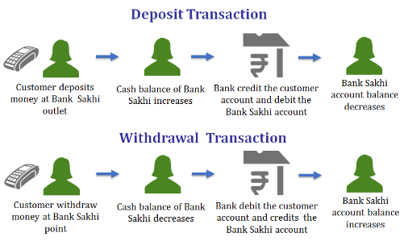

1. Facilitator will now give an exercise to participants to explain the concept of settlement account. The time to complete the exercise is 10 mins. **Slide – Session 5 - 8**

Opening Cash Balance Rs. 10000

Opening digital cash Balance Rs. 2000

Calculate closing cash in Hand and digital cash balance

|  |  |
| --- | --- |
| Type of Transaction | Amount in Rs. |
| Deposit | 500 |
| Withdrawal | 2000 |
| Transfer (Account to account) | 8000 |
| Deposit | 3500 |

Once the participants have finished the exercise, the facilitator will check with them for the answers. The answer for this exercise is as follows:

|  |  |
| --- | --- |
| Closing cash in hand | 12,000 |
| Digital cash balance | 0 |

Explain the participants the equation given below:

|  |
| --- |
| Closing cash in hand= Opening cash in hand+ deposit-withdrawal |
| Digital cash balance=Opening digital cash balance+ withdrawal- deposit |

Since the transfer transaction is account to account there will be no effect on cash in hand and digital cash balance.

1. Close the session and move to next session ‘Skills, Roles and Responsibilities of Bank Sakhi’.

# Session 6: Skills, Roles and Responsibilities of Bank Sakhi

|  |  |  |
| --- | --- | --- |
| Overview |  | This session helps participants to understand various risks involved in their business correspondent work and the strategies to mitigate those risks. |
| Session Objectives |  | By the end of this session participants will be able to:   * Understand the requirements of ideal bank sakhi * Roles and responsibilities * Dos and Don’ts for bank sakhi |
| Duration |  | 60 min |
| Methodology and Steps |  | **Presentation and Group Exercise**  Step 1: Requirements of ideal bank sakhi (30 minutes)  Provides key points regarding skill sets required in an ideal bank sakhi (2 Slides).  Step 2: Roles and responsibilities of bank sakhi (30 minutes)  Provides information on roles and responsibilities of bank sakhi during various stages of their growth journey and their responsibilities towards JEEViKA’s CBOs. It also provides operational dos and don’ts for bank sakhis. (10 Slides). |
| Resources |  | PowerPoint presentation titled ‘“Skills, Roles and Responsibilities of Bank Sakhi” |
| Trainers’ Preparation |  | Trainers should do the following before starting the session:   * Prepare required presentation |

## Presentations

**Slides**

**Session 6 – 1: Skills, roles and responsibilities of Bank Sakhi**

* Requirements to become good bank sakhi
* Roles and responsibilities of bank sakhi
* Dos and Don’ts of bank sakhis

|  |  |  |
| --- | --- | --- |
| Session 6 - 1 | Prepared by BASIX Consulting and Technology Services Ltd | 60 |

**Session 6 – 2: What are the skills required to become a good bank sakhi ?**

|  |  |  |
| --- | --- | --- |
| Session 6 - 2 | Prepared by BASIX Consulting and Technology Services Ltd | 61 |

**Session 6 – 3: Characteristics of Bank Sakhi**

**Functional Skills**

* Able to do simple numerical calculations (such as addition, subtraction)
* Be able to handle micro ATM/laptop and other accessories and has some understanding of computer and mobile technology
* Have basic English language skills (reading and writing)

**Personal Competence**

* Be friendly and sincere
* Be an active and fast learner (learn how to use micro ATM/laptop, and related processes)
* Be able to motivate others to use financial services
* Have good rapport with all sections of the society
* Not be a defaulter to any financial institution
* Not have been reported against for malpractice or fraud
* Be mobile and have assurance of family support
* Be able to invest working capital

|  |  |  |
| --- | --- | --- |
| Session 6 - 3 | Prepared by BASIX Consulting and Technology Services Ltd | 62 |

**Session 6 – 4: Qualities to become successful Bank Sakhi**

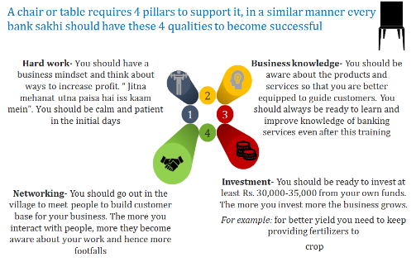

|  |  |  |
| --- | --- | --- |
| Session 6 - 4 | Prepared by BASIX Consulting and Technology Services Ltd | 63 |

**Session 6 – 5: Bank Sakhi Growth Journey**

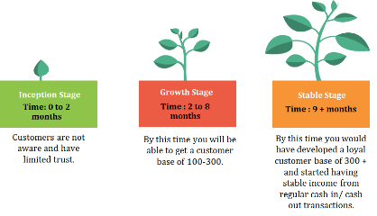

|  |  |  |
| --- | --- | --- |
| Session 6 - 5 | Prepared by BASIX Consulting and Technology Services Ltd | 64 |

**Session 6 – 6: Exercise**

Write down roles and responsibilities of bank sakhi for each stage of growth journey

|  |  |  |
| --- | --- | --- |
| Session 6 - 6 | Prepared by BASIX Consulting and Technology Services Ltd | 65 |

**Session 6 – 7: Roles and Responsibilities of Bank Sakhi (1/3)**

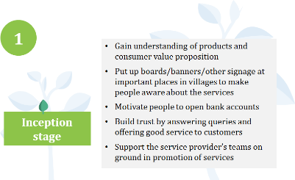

|  |  |  |
| --- | --- | --- |
| Session 6 - 7 | Prepared by BASIX Consulting and Technology Services Ltd | 66 |

**Session 6 – 8: Roles and Responsibilities of Bank Sakhi (2/3)**

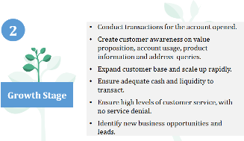

|  |  |  |
| --- | --- | --- |
| Session 6 - 8 | Prepared by BASIX Consulting and Technology Services Ltd | 67 |

**Session 6 – 9: Roles and Responsibilities of Bank Sakhi (3/3)**

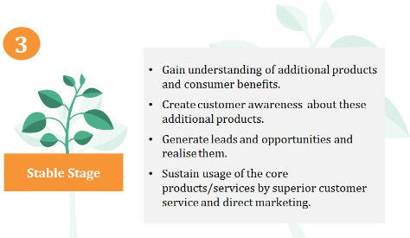

|  |  |  |
| --- | --- | --- |
| Session 6 - 9 | Prepared by BASIX Consulting and Technology Services Ltd | 68 |

**Session 6 – 10: What are your roles and responsibilities towards JEEViKA’s CBOs?**

|  |  |  |
| --- | --- | --- |
| Session 6 - 10 | Prepared by BASIX Consulting and Technology Services Ltd | 69 |

**Session 6 – 11: Roles and responsibilities towards JEEViKA CBOs**

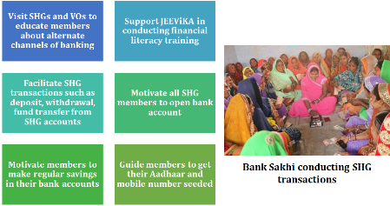

|  |  |  |
| --- | --- | --- |
| Session 6 - 11 | Prepared by BASIX Consulting and Technology Services Ltd | 70 |

**Session 6 – 12: Do’s of Bank Sakhi (1/2)**

* You should keep the BC point / CSP outlet open during operational hours on all days as stipulated.
* Keep the premises clean and organised
* Any change in timings shall be approved by the bank and shall be mentioned on notice board at the CSP location
* You should display the marketing collaterals containing your details such as name, BC agent code provided by the bank or corporate BC at the outlet
* You should ensure that the collateral / certificates / posters are properly displayed and visible to the customers.
* You should open your outlet in the allotted location and shall not move BC location without approval from the bank/link branch
* Maintain sufficient liquidity or cash at the outlet to avoid situations of transactions denial

|  |  |  |
| --- | --- | --- |
| Session 6 - 12 | Prepared by BASIX Consulting and Technology Services Ltd | 71 |

**Session 6 – 13: Do’s of Bank Sakhi (2/2)**

* Maintain record of each and every transaction in the physical register
* You should actively engage with customers and request them to update their mobile numbers, addresses and Aadhaar number in their bank accounts
* Communicate to customers any information on product features, changes in product processes or bank processes, as intimated to you by bank or corporate BC
* You should always talk to customers politely even in situations when customers are complaining. Guide and support customers in getting their grievances resolved

|  |  |  |
| --- | --- | --- |
| Session 6 - 13 | Prepared by BASIX Consulting and Technology Services Ltd | 72 |

**Session 6 – 14: Don’ts of bank sakhi**

* You should NOT overcharge customers. All charges should be displayed in the outlet
* You should not conduct transactions in the absence of the customers. Do not accept cash or give cash till you receive transaction completion/successful message.
* You should not conduct any transactions such as deposit, fund transfer from your bank account on behalf of customers or any third party. For example: do not use your savings account or current account to send money to any third person on behalf of a customer.
* Do not divulge any sensitive information pertaining to the customer’s account. Always maintain customers’ privacy.

|  |  |  |
| --- | --- | --- |
| Session 6 - 14 | Prepared by BASIX Consulting and Technology Services Ltd | 73 |

## Facilitation Notes

1. Ask the participants, what are the characteristics required in a bank sakhi so that she can perform her job efficiently. Encourage all the participants to come up with at least one characteristics. Display **Slide - Session 6 - 3** when you feel that the participants have covered almost all the points. Briefly run through all the characteristics on **Slide - Session 6 - 3**
2. Display **Slide - Session 6 - 4** and tell the participants that like all other businesses, bank sakhis should possess 4 essential qualities – Hard work, Networking, Business Knowledge and Investment. Emphasis that the bank sakhi work is an entrepreneurship activity and not a fixed salaried job. So growing the business is in their hands.
3. Display **Slide - Session 6 -** **5** and explain the various stages in the growth journey of a bank sakhi. There are 3 stages in the growth journey:
4. **Inception Stage: 0 to 2 months**- Key focus areas in this stage for bank sakhi will be acquiring customer base, marketing and branding and building customer trust
5. **Growth Stage**: **2 to 8 months**- Key focus areas in this stage for bank sakhi will be regular transactions, expand customer base, identify expansion opportunities and ensuring high quality service
6. **Stable Stage**: **9+ months**- Key focus areas in this stage for bank sakhi will be on cross-selling other financial products of the bank
7. Divide the participants into three groups and allot one stage- Inception, Growth and Stable to each of the group. Ask each of the groups to list down roles and responsibilities of bank sakhi under their allotted stage. Give around 5 mins to the groups to list down the roles and responsibilities. Then ask each group to come forward and present their points of roles and responsibilities.
8. Display **Slides** **from Session 6 - 7** to **Session 6 - 9** to debrief the participants on roles and responsibilities of bank sakhi under each stage of journey.
9. Ask the participants, apart from the roles and responsibilities that they have just learnt, what additional roles and responsibilities they have towards JEEViKA’s CBOs.

Display **Slide - Session 6 - 11** to emphasis on roles and responsibilities of bank sakhi towards JEEViKA’s CBOs

1. Display **Slides from Session 6 - 12 to Session 6 - 14** and explain in detail to the participants’ dos and don’ts for bank sakhi. Emphasis to the participants that bank sakhis will be monitored and required action will be taken in case they do not follow these dos and don’ts.
2. Close the session and proceed to next session “Risk Management”.

# Session 7: Risk Management

|  |  |  |
| --- | --- | --- |
| Overview |  | This session helps participants to understand various risks involved in their business correspondent work and the strategies to mitigate those risks. |
| Session Objectives |  | By the end of this session participants will be able to:   * Understand the importance and how to maintain business records * Understand some basic techniques of fraud prevention * Identify fake currency notes |
| Duration |  | 90 min |
| Methodology and Steps |  | **Presentation, Video and Group Exercise**  Step 1: Importance of record keeping (40 minutes)  Provides key points as to why bank sakhis should maintain daily records of their business. It also provides sample formats of registers that bank sakhis should maintain, adopt and update daily (9 Slides).  Step 2: Fraud prevention (20 minutes)  Provides information on how bank sakhi can prevent transactional and physical cash risks in their business. It also provides important guidelines on which bank sakhis need to educate their customers to mitigate incidents of fraud. (4 Slides).  Step 3: Fake currency note detection (20 minutes)  Provides information on security features in currency notes of Rs. 2,000, Rs.500, Rs.200 and Rs.50. (2 Slides). |
| Resources |  | PowerPoint presentation titled ‘“Risk Management”.  Handout 7.1- Register formats  Handout 7.2- Security features in currency notes  Video titled-Security features of the new Rs. 2000 and Rs. 500 notes. |
| Trainers’ Preparation |  | Trainers should do the following before starting the session:   * Prepare required presentation * Prepare sufficient copies of handouts for distribution * Keep ready the Video |

## Presentations

**Slides**

**Session 7 - 1: Risk Management**

* Importance of record keeping
* Types of registers to be maintained
* Fraud prevention
* Fake currency note detection

|  |  |  |
| --- | --- | --- |
| Session 7 - 1 | Prepared by BASIX Consulting and Technology Services Ltd | 75 |

**Session 7 - 2: Case**

Phool devi is a bank sakhi in Punpun block of Patna district. Her CSP outlet is now 6 months old. JEEViKA arranged a visit of some foreign delegations to her outlet. Delegates asked Phool devi, how is her business doing? Phool Devi replied its going good and she is enjoying the work of bank sakhi. Then delegates asked her how many bank accounts she has opened in the last 6 months and what is the average number of transactions at her outlet. Phool Devi couldn’t answer these questions. Then delegates asked her how much profit she is making from this bank sakhi work? Phool Devi said she doesn’t know whether business is making profit or not.

1. Can you all tell why Phool Devi was not able to answer questions of foreign delegates?
2. What she should do so that she is able to answer questions about her business easily and know whether her business is making profit or not?

|  |  |  |
| --- | --- | --- |
| Session 7 - 2 | Prepared by BASIX Consulting and Technology Services Ltd | 76 |

**Session 7 - 3: Record Keeping and Data Management**

You should maintain detailed record of your business on daily basis by noting down each and every transactions and activities related to the business.

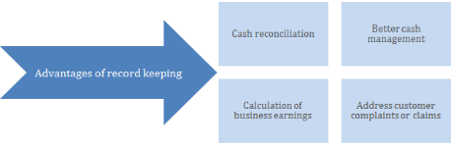

|  |  |  |
| --- | --- | --- |
| Session 7 - 3 | Prepared by BASIX Consulting and Technology Services Ltd | 77 |

**Session 7 - 4: Registers to be maintained by bank sakhi**

You should maintain the following registers **daily** and **diligently**

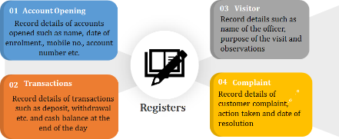

|  |  |  |
| --- | --- | --- |
| Session 7 - 4 | Prepared by BASIX Consulting and Technology Services Ltd | 78 |

**Session 7 - 5: Opening Page Format- Sample**

The opening page of all the registers- Account Opening, Transaction, Visitor and Complaint should have the following format

|  |  |
| --- | --- |
| **Name of Bank Sakhi** |  |
| **Code of Bank Sakhi** |  |
| **Bank Name** |  |
| **Link Branch** |  |
| **Register Name** |  |
| **Start Date** | Date at which the register was started |
| **End Date** |  |

Date at which the register was closed. This needs to be updated at the time of closing the register when the pages in the register get over

|  |  |  |
| --- | --- | --- |
| Session 7 - 5 | Prepared by BASIX Consulting and Technology Services Ltd | 79 |

**Session 7 - 6: Account Opening Register Format- Sample**

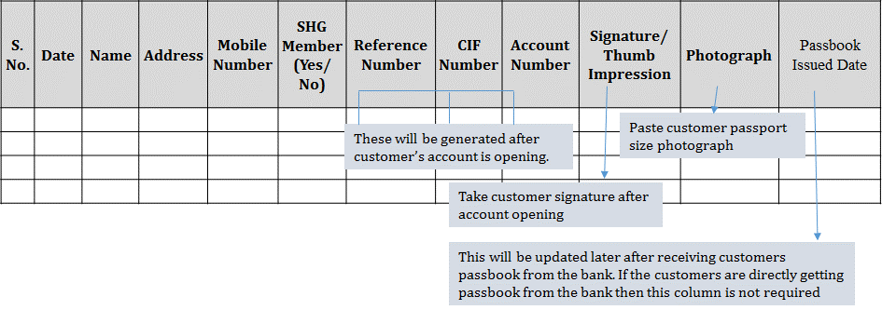

|  |  |  |
| --- | --- | --- |
| Session 7 - 6 | Prepared by BASIX Consulting and Technology Services Ltd | 80 |

**Session 7 - 7: Transaction Register Format- Sample (1/2)**

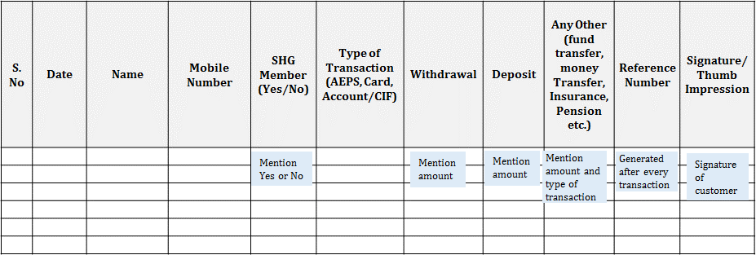

**All the transactions-** successful and failed should be recorded in the register. For failed transactions just put a cross along with reference number in the Reference Number column.

|  |  |  |
| --- | --- | --- |
| Session 7 - 7 | Prepared by BASIX Consulting and Technology Services Ltd | 81 |

**Session 7 - 8: Transaction Register Format- Sample (2/2)**

|  |  |  |  |
| --- | --- | --- | --- |
| Opening Cash Balance | Physical cash at the beginning of the day | Physical cash additions during the day | Note down all the amounts of physical cash additions during the day to conduct transactions. For example: you have 2 times refueled with amounts of Rs. 100,000 then Rs. 50,000. Then total value of additions will be Rs. 150,000 |
| Closing Cash Balance = (Opening cash balance+ additions during the day + total cash in transactions)- total cash out transactions | Calculate using the given formula at the end of day and then match with the physical cash in drawer |
| Opening Digital Cash Balance | Balance in operating bank account at the beginning of the day | Digital cash additions during the day | Note down all the amounts of additions made in the operating account to conduct transactions. For example during the day you have made deposit of Rs. 60,000 in the operating account then deposit of Rs. 5000 in the evening. So total amount of additions will be Rs. 65000 |
| Closing Digital Cash Balance= (Opening digital cash balance+ additions during the day + total cash out transactions)- total cash in transactions | Calculate using the given formula at the end of day and then match with the balance shown in the operating bank account |

This table needs to be made for each day and would help in cash reconciliation

|  |  |  |
| --- | --- | --- |
| Session 7 - 8 | Prepared by BASIX Consulting and Technology Services Ltd | 82 |

**Session 7 - 9: Visitor Register Format-Sample**

|  |  |  |  |  |  |  |  |
| --- | --- | --- | --- | --- | --- | --- | --- |
| **Serial Number** | **Date and Time** | **Name** | **Mobile** | **Institution and Designation** | **Purpose of Visit** | **Comment** | **Signature/ Thumb Impression** |
|  |  |  |  |  |  |  |  |
|  |  |  |  |  |  |  | Signature of visitor |
|  |  |  |  |  |  |  |  |
|  |  |  |  |  |  |  |  |
|  |  |  |  |  |  |  |  |

|  |  |  |
| --- | --- | --- |
| Session 7 - 9 | Prepared by BASIX Consulting and Technology Services Ltd | 83 |

**Session 7 - 10: Complaint Register Format-Sample**

|  |  |  |  |  |  |  |  |
| --- | --- | --- | --- | --- | --- | --- | --- |
| **Serial Number** | **Date** | **Name** | **Mobile Number** | **Complaint/ Suggestions** | **Signature/ Thumb Impression** | **Steps Taken** | **Date of Resolution** |
|  |  |  |  |  |  | Mention the steps taken to resolve complaint. This will be updated by bank sakhi | Mention date on which problem was resolved |
|  |  |  |  |  |  |  |  |
|  |  |  |  |  |  |  |  |
|  |  |  |  |  |  |  |  |
|  |  |  |  |  |  |  |  |

|  |  |  |
| --- | --- | --- |
| Session 7 - 10 | Prepared by BASIX Consulting and Technology Services Ltd | 84 |

**Session 7 - 11: Exercise**

Do you see any risks in your work and if yes, what are the risks and what precautions needs to be taken?

|  |  |  |
| --- | --- | --- |
| Session 7 - 11 | Prepared by BASIX Consulting and Technology Services Ltd | 85 |

**Session 7 - 12: You must take certain pre-cautions in your operations**

**Transactional security**

* You must always keep your PINs a secret, especially while conducting transactions
* Do not handover your device to anyone else for transactions
* You must NEVER ask the customers for their PINs. You should handover the microATM or card reader to the customers and ask them to enter their PIN themselves
* Always handover cash or accept cash only after receiving transaction successful message
* After handing over cash to customers, insist them to count cash in front of you
* After accepting cash from customers, do check the currency notes for fake currency notes
* Always handover the transaction receipt to the customer after completion of transaction to avoid future disputes
* Encourage customers to get their mobile numbers seeded in the bank account to receive transaction status to maintain transparency
* Encourage customers to get Aadhaar seeded so that they can opt for safe AePS transactions from their bank account

|  |  |  |
| --- | --- | --- |
| Session 7 - 12 | Prepared by BASIX Consulting and Technology Services Ltd | 86 |

**Session 7 - 13: Take security measures to safeguard physical cash**

**Physical security**

* Your outlet should be secured against any unauthorized entry
* Ensure cash tills and transaction registers are not exposed and are securely locked up at the end of the day
* If you have high volumes then should consider having a safe for storing cash

You must always be vigilant when conducting transactions

There is always a risk when moving large amounts of cash when travelling to and from the bank/ATM. You must take safety precautions

|  |  |  |
| --- | --- | --- |
| Session 7 - 13 | Prepared by BASIX Consulting and Technology Services Ltd | 87 |

**Session 7 - 14: You should create safe environment for customers**

Educate your customers on following dos and don’ts of transactions

**Do’s**

* Keep eyes on microATM/card reader and ATM card during transactions
* Read the screen before giving biometric authentication
* Do not keep your PIN in writing
* Pay only for the amount displayed on screen of laptop/microATM
* Change PIN regularly and keep a track of account balance
* Take SMS alert facility to keep track of transactions from the account
* Inform bank immediately about lost or stolen ATM card and get the card blocked.

**Don'ts**

* Do not allow agent to swipe card on machine other than microATM/card reader
* Do not leave transaction receipts for failed transactions with agent as there are chances of theft of identity information
* Do not make simple PIN like 1234
* Do not disclose PIN to anyone not even to bank officials
* Do not keep PIN and card together
* Do not give PIN and card details to callers from unknown numbers

|  |  |  |
| --- | --- | --- |
| Session 7 - 14 | Prepared by BASIX Consulting and Technology Services Ltd | 88 |

**Session 7 - 15: Checking Fake currency**

* Has anyone ever received any fake currency? If yes, how did you know it was a fake currency?
* What all do you check when you receive notes of Rs.2000, Rs.500 and Rs. 200

|  |  |  |
| --- | --- | --- |
| Session 7 - 15 | Prepared by BASIX Consulting and Technology Services Ltd | 89 |

**Session 7 - 16: Security Features of Rs. 2000 and Rs. 500**

[Start video on Security features of Rs. 2000 and Rs. 500](https://www.youtube.com/watch?v=02ytq-MzpD4)

|  |  |  |
| --- | --- | --- |
| Session 7 - 16 | Prepared by BASIX Consulting and Technology Services Ltd | 90 |

## Facilitation Notes

1. Read out the case of Phool Devi given on **Slide - Session 7 - 2**. After explaining the case to the participants, ask them why Phool Devi is not able to answer questions related to transaction volume and profit of her business. What Phool Devi should do so that she is able to answer such questions in future?
2. Note the responses given by the participants and guide them towards the answer that Phool Devi should maintain business records to track business transactions and profit.
3. After establishing the concept of record keeping, display the **Slide - Session 7 - 3** to discuss what are the benefits of record keeping for bank sakhis?

The key benefits of record keeping are:

1. **Reconciliation of physical and digital cash at the end of the day**- Reconciliation of cash helps in identification or prevention of cash related frauds
2. **Able to achieve better cash management** by predicting the future requirements of cash after analyzing the transaction history
3. **Helps in calculation of earnings from BC business-** If all the transactions are duly recorded in the registers, you can easily calculate your commissions and tally it with the amount credited. You would be able to report to the bank or corporate BC in case of any discrepancy
4. **Helps in better addressing customer claims or complaints in future-** For example: a customer claiming later that his account balance is less than what it should be
5. Discuss with the participants what are the key information related to business they should be recording and in what frequency?
6. Display **Slide - Session 7 - 4** and inform the participants they should maintain 4 types of registers- **Account opening, Transaction, Visitor and Complaint.** Explain the relevance of each of the registers. These registers should be **updated daily** and the entry in register should happen in the relevant register immediately after the transaction/account opening. If the entries are not made immediately then there are chances of error as bank sakhi might forget the information related to the transaction.
7. Discuss the sample formats of Account Opening, Transaction, Visitor and Complaint registers given on **Slides (Session 7-5 to Session 7-10).** Explain the meaning of each of the columns in all the formats to the participants- Time 20 mins.
8. Inform the participants that they would be required to follow these formats and maintain all the required registers diligently. These registers need to be purchased by bank sakhis on their own. There will be monitoring by JEEViKA team to check whether bank sakhis are updating their business records daily or not.
9. Distribute the Handout 7.1 Register Formats to the participants for their future reference.
10. Divide the participants in 4 groups and ask them to write points for the question” Do you see any risks in your work and if yes, what type of precautions you will take”. Give them 5 minutes to write their points. Then each group will share their points in the plenary. Time for discussion will be 5 minutes
11. Display S**lides from Session 7 - 12 to Session 7 - 14** to debrief the participants about the key transactional and physical security risks and the required precautions. Time 10 minutes
12. Ask the participants, whether anyone in the class has ever received any fake currency and how did she come to know that it was a fake currency?
13. Check with the participants whether they are aware about the security features in Rs. 2000, Rs. 500, Rs. 200 and Rs. 50.
14. Show the video titled “Security features of Rs. 2000 and Rs. 500” to the participants.
15. Clarify the doubts of participants if any related to security features by demonstrating using real currency notes of Rs. 2000 and Rs. 500
16. Distribute the handout on security features of Rs. 2000, Rs. 500, Rs. 200 and Rs.50. Allow time to the participants to go through the handout and clarify their doubts if any.
17. Close the session and proceed to next session “Cost and Revenue of BC Model”

# Session 8: Cost and Revenue of BC model

|  |  |  |
| --- | --- | --- |
| Overview |  | This session helps participants understand the investment and return from setting up a CSP.. |
| Session Objectives |  | By the end of this session participants will be able to:   * Capital and operational expenditure for setting up BC model * Support from JEEViKA to bank sakhis * Commission structure |
| Duration |  | 90 min |
| Methodology and Steps |  | **Presentation and Group Exercise**  Step 1: Capital and operational expenditure for setting up BC model  (30 minutes)  Step 2: Support from JEEViKA to bank sakhis (20 minutes)  Step 3: Earning potential of a bank sakhi (20 minutes)  Step 4: Target setting exercise for bank sakhis (20 minutes) |
| Resources |  | PowerPoint presentation.  Handout: Commission structure |
| Trainers’ Preparation |  | Trainers should do the following before starting the session:   * Prepare required presentation * Prepare sufficient copies of Handout for distribution |

## Presentations

**Slides**

**Session 8 - 1: Cost and revenue of BC model**

1. Capital and operational expenditure for setting up BC model
2. Support from JEEViKA to bank sakhis
3. Earning potential of a bank sakhi
4. Target setting exercise for bank sakhis

|  |  |  |
| --- | --- | --- |
| Session 8 - 1 | Prepared by BASIX Consulting and Technology Services Ltd | 92 |

**Session 8 - 2: Capital Expenses**

|  |  |  |  |  |  |
| --- | --- | --- | --- | --- | --- |
| **S. No** | **Particulars** | **Unit Cost** | **Unit** | **Total Cost** | **Remarks** |
| **1** | Computer or Laptop | 35000 | 1 | 35000 | Bank Sakhi will be the owner of computer/laptop |
| **2** | Printer cum scanner | 10000 | 1 | 10000 | Bank Sakhi will be the owner of printer |
| **3** | Biometric Device | 3400 | 1 | 5000 | Bank Sakhi will be the owner of Biometric Device  (Bank Sakhi will have to get the device registered before use of this device) |
| **4** | Micro ATM | 5000 | 1 | 5000 | No cash payment has to be done. A FD worth 5000 has to be opened with MBGB and the security paper has to be submitted to C-DOT for procurement of micro ATM.  If bank sakhi stops working, device needs to be returned to C-DOT and Rs. 5000 will be refunded |
| **5** | Internet Connection | 2000 | 1 | 2000 | Expense needs to be done once to get modem/ dongle device. After that, there will be monthly expense of recharging the connection. You may also use wi-fi hotspot if you have smart phone |
| **6** | Other Equipment (Furniture) |  |  | 10000 |  |
|  | Total Expense |  |  | 67000 |  |

|  |  |  |
| --- | --- | --- |
| Session 8 - 2 | Prepared by BASIX Consulting and Technology Services Ltd | 93 |

**Session 8 - 3: Operational Expenses**

|  |  |
| --- | --- |
| **Type of Expenditures** | **Amount (in Rs.)** |
| Rent | 750-1500 |
| Electricity | 250- 500 |
| Internet | 150-200 |
| Cash management ( Transportation expenses) | 600-800 |
| Stationery (for registers and microATM printer roll, A4 papers for printout) | 250-300 |
| Printer Cartridge |  |
| **Total Monthly Operational Expenses** | **2,000- 3,300** |

The expenses mentioned above are indicative and there could be variations depending on volume of transactions and also place of bank Sakhi outlet.

|  |  |  |
| --- | --- | --- |
| Session 8 - 3 | Prepared by BASIX Consulting and Technology Services Ltd | 94 |

**Session 8 - 4: Financial Support from JEEViKA**

|  |  |  |  |
| --- | --- | --- | --- |
| **S. No.** | **Fund Amount (in Rs.)** | **Fund Type** | **Details** |
| **1** | 50,000 | Zero interest loan from VO | * In this loan from VO, you do not have to pay any interest on the amount borrowed. You will have to return Rs. 1000 per month to VO in 50 months. * JEEViKA is providing this loan for purchase of Laptop and other equipment |
| **2** | 10,000 | Grant | * JEEViKA is providing this grant for furniture and marketing collaterals at CSP outlets, to ensure uniformity in appearance of JEEViKA supported CSP outlets |
| **3** | 15,000 | Grant | * JEEViKA provides honorarium to bank sakhis @2500 per month for the first 6 months of operations. Out of which Rs. 10,000 will be provided at the time of starting operations and VO will provide remaining Rs. 5000 after 6 months * This honorarium is being provided to help bank sakhis to meet their operational expenses. |

|  |  |  |
| --- | --- | --- |
| Session 8 - 4 | Prepared by BASIX Consulting and Technology Services Ltd | 95 |

**Session 8 - 5: Commission**

|  |  |  |
| --- | --- | --- |
| **S. No.** | **Functions** | **Honorarium /Commission** |
| **1** | Min.20 days login and 50 transactions | 3500 +1500 = 5000  (1500 will be given to bank Sakhi only from 3rd month) |
| **2** | Account opening | Rs. 20 in two stages   1. Rs. 10 at the time of opening the account and remaining 2. Rs. 10 after minimum balance of Rs. 100 in the account |
| **3** | Transaction (withdrawal and deposit) and remittance | 0.32% of the amount involved  (Maximum cap of Rs. 50 per account per day) |
| **4** | Aadhaar seeding | 4 |
| **5** | PMJJBY | 24 |
| **6** | PMSBY | 1 |
| **7** | Atal Pension Yojana (enrollment + 12 monthly installments) | 40 |
| **8** | FD/RD account opening + amount transaction | 4 + 0.32% of transacted amount |
| **9** | Loan Appraisal | 300 |

|  |  |  |
| --- | --- | --- |
| Session 8 - 5 | Prepared by BASIX Consulting and Technology Services Ltd | 96 |

## Facilitation Notes

1. Facilitator will now explain the various expenses associated with establishing a CSP.

Opening a CSP Centre is a business and not a job. As any business require some amount of investment, opening a CSP also require some amount of investment.

1. There are two kind of expenses

* Capital expenses and
* Operational Expenses

1. Capital Expenses: Capital expenses are business expenses which are one time in nature like building, furniture, machinery etc.
2. Operational expenses: Operational expenses are expenses which are required for day to day running of the business-like rent bill, electricity bill etc.
3. With the help of **Slide- Session 8 - 2** facilitator will explain the capital expenditure

|  |  |  |  |  |  |
| --- | --- | --- | --- | --- | --- |
| S. No | Particulars | Unit Cost | Unit | Total Cost | Remarks |
| 1 | Computer or Laptop | 35000 | 1 | 35000 | Bank Sakhi will be the owner of computer/laptop |
| 2 | Printer cum scanner | 10000 | 1 | 10000 | Bank Sakhi will be the owner of printer |
| 3 | Biometric Device | 3400 | 1 | 5000 | Bank Sakhi will be the owner of Biometric Device  (Bank Sakhi will have to get the device registered before use of this device) |
| 4 | Micro ATM | 5000 | 1 | 5000 | No cash payment has to be done. A FD worth 5000 has to be opened with MBGB and the security paper has to be submitted to C-DOT for procurement of micro ATM.  If bank sakhi stops working, device needs to be returned to C-DOT and Rs. 5000 will be refunded |
| 5 | Internet Connection | 2000 | 1 | 2000 | Expense needs to be done once to get modem/ dongle device. After that, there will be monthly expense of recharging the connection. You may also use wi-fi hotspot if you have smart phone |
| 6 | Other Equipment(Furniture) |  |  | 10000 |  |
|  | Total Expenditure |  |  | 67000 |  |

The expenses listed above are one time

1. Facilitator will now explain the operational expenses to participants with help of   
   **Slide – Session 8 - 3**

|  |  |
| --- | --- |
| Type of Expenditures | Amount (in Rs.) |
| Rent | 750-1500 |
| Electricity | 250- 500 |
| Internet | 150-200 |
| Cash management *( Transportation expenses)* | 600-800 |
| Stationery (for registers and microATM printer roll, A4 papers for printout) | 250-300 |
| Printer Cartridge | 200-300 |
| Total Monthly Operational Expenses | **2,200- 3,600** |

1. Apart from these two expenses bank Sakhi will have to invest around Rs. 30,000 for running the business. This amount will be used to serve the customer transaction like deposit and withdrawal.
2. Now facilitator will explain the support provided by JEEViKA to bank sakhi for establishing and running the CSP centre with help of **Slide – Session 8 - 4**

|  |  |  |  |
| --- | --- | --- | --- |
| S. No. | Fund Amount (in Rs.) | Fund Type | Details |
| 1 | 50,000 | Zero interest loan from VO | In this loan from VO, you do not have to pay any interest on the amount borrowed. You will have to return Rs. 1000 per month to VO for 50 months.  JEEViKA is providing this loan for purchase of Laptop and other equipment |
| 2 | 10,000 | Grant | JEEViKA is providing this grant for furniture and marketing collaterals at CSP outlets, to ensure uniformity in appearance of JEEViKA supported CSP outlets |
| 3 | 15,000 | Grant | JEEViKA provides honorarium to bank sakhis @2500 per month for the first 6 months of operations. Out of which Rs. 10,000 will be provided at the time of starting operations and VO will provide remaining Rs. 5000 after 6 months  This honorarium is being provided to help bank sakhis to meet their operational expenses. |

1. As we have discussed earlier that running a CSP is a business and Bank Sakhi will earn the commission on every transaction from the bank. There is no upper limit on the commission and it depends on the business volume of the bank Sakhi. Explain it with help of   
   **Slide – Session 8 - 5**

|  |  |  |
| --- | --- | --- |
| S. No. | Functions | Honorarium /Commission |
| 1 | Min.20 days login and 50 transactions | 3500 +1500 = 5000  (1500 will be given to bank Sakhi only from 3rd month) |
| 2 | Account opening | Rs. 20 in two stages  Rs. 10 at the time of opening the account and remaining  Rs. 10 after minimum balance of Rs. 100 in the account |
| 3 | Transaction (withdrawal and deposit) and remittance | 0.32% of the amount involved  (Maximum cap of Rs. 50 per account per day) |
| 4 | Aadhaar seeding | 4 |
| 5 | PMJJBY | 24 |
| 6 | PMSBY | 1 |
| 7 | Atal Pension Yojana (enrollment + 12 monthly installments) | 40 |
| 8 | FD/RD account opening + amount transaction | 4 + 0.32% of transacted amount |
| 9 | Loan Appraisal | 300 |

1. When bank pay commission to Bank Sakhi they deduct 5% Tax Deducted at Source (TDS) also. Bank Sakhi can claim this amount when they file their income tax return.
2. Close the session and move to next session ’Marketing and Customer Service’

# Day - 3

# Session 9: Marketing and Customer Service

|  |  |  |
| --- | --- | --- |
| Overview |  | This session helps participants to understand marketing activities to be undertaken by them and how to better serve their customers. |
| Session Objectives |  | By the end of this session participants will be able to:   * Be able to pitch with prospective customers * Know how to handle difficult customers * Marketing activities for bank sakhis * Branding essentials * How to better serve customers * Grievance redressal mechanism for bank sakhis and customers * Customer education |
| Duration |  | 240 min |
| Methodology and Steps |  | **Presentation, Role Play and Plenary Discussion**  Step 1: Marketing and branding (120 minutes)  Provides key points as to how bank sakhis can market and pitch prospective customers. Bank sakhis will practice pitching prospective customers  Step 2: Customer Service (120 minutes)  Provides key points as to how bank sakhis can better serve their customers and how to handle difficult customers. Bank Sakhis will practice handling difficult customers. |
| Resources |  | PowerPoint presentation “Marketing and Customer Service”.  Handout 9.1 Grievance Redressal Mechanism |
| Trainers’ Preparation |  | Trainers should do the following before starting the session:   * Prepare required presentation * Prepare sufficient copies of Handout for distribution |

## Presentations

**Slides**

**Session 9 - 1: Marketing and Customer Service**

* How to pitch prospective customers
* Basic marketing activities for bank sakhis
* Branding essentials
* How to better serve customers
* Grievance redressal management
* Customer education

|  |  |  |
| --- | --- | --- |
| Session 9 - 1 | Prepared by BASIX Consulting and Technology Services Ltd | 98 |

**Session 9 - 2: Value Proposition for Customers for transacting with bank sakhi**

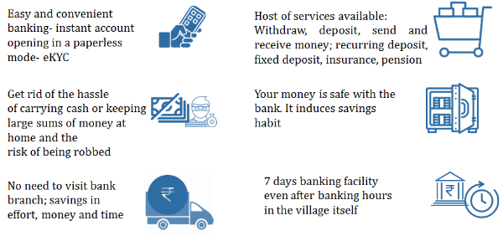

|  |  |  |
| --- | --- | --- |
| Session 9 - 2 | Prepared by BASIX Consulting and Technology Services Ltd | 99 |

**Session 9 - 3: What is a Customer Pitch?**

Pitching is about understanding what your customer is most interested in, and developing a dialog that enables you to connect with the customer

**How to develop effective customer pitch?**

1. First patiently listen to your customers
2. Create a story; emotional story that helps to draw customer’s attention
3. Narrate local and relevant examples to explain how financial products can help your customers.
4. Assess needs of your customer
5. Develop a pitch according to the target customer needs

**Quality of good pitch!**

* Understanding the customer needs
* Communicating the benefits of the product in the language understood by the customer.

|  |  |  |
| --- | --- | --- |
| Session 9 - 3 | Prepared by BASIX Consulting and Technology Services Ltd | 100 |

**Session 9 - 4: How to Develop Customer Pitch**

You should maintain the following registers **daily** and **diligently**

|  |  |
| --- | --- |
| **You Should Understand…** | **What to Inform** |
| Are you aware about different customer segments? | 1. Understand value proposition for different customer segments from the product you are selling. Example: RD, FD |
| Do you know the strengths of your financial service provider? | 1. Explain financial service provider’s strength |
| Can you explain customer about the features and benefits of different types of financial products? | 1. Explain the key features of the products/services- safety, security, accessibility, interest earned etc. |
| Can you explain the process to avail various services offered through your CSP point? | 1. Explain key processes to avail services at CSP point such as documents required, eligibility criteria etc |

|  |  |  |
| --- | --- | --- |
| Session 9 - 4 | Prepared by BASIX Consulting and Technology Services Ltd | 101 |

**Session 9 - 5: Exercise**

* Divide yourself in a groups of 3-4 people
* Each group shall pick one customer segment from the list below:
* Students
* Women- House wives
* Daily wage earners
* Salaried employees
* Farmers
* Old aged people
* Each group will develop their pitch to convince the chosen customer segment to open account or cash deposit at CSP outlet
* Trainer will randomly choose one group for demonstration of their pitch. One member of the group will enact as bank sakhi and will try to convince the trainer to open bank account or make cash deposit at CSP outlet. The trainer will enact the role of the chosen customer segment by the selected group.

|  |  |  |
| --- | --- | --- |
| Session 9 - 5 | Prepared by BASIX Consulting and Technology Services Ltd | 102 |

**Session 9 - 6: Delivered a Good Pitch- What to Expect Next**

* Understand value proposition for different customer segments from the product you are selling. Example: RD, FD
* Explain financial service provider’s strength
* Explain the key features of the products/services- safety, security, accessibility, interest earned etc.
* Explain key processes to avail services at CSP point such as documents required, eligibility criteria etc.

|  |  |  |
| --- | --- | --- |
| Session 9 - 6 | Prepared by BASIX Consulting and Technology Services Ltd | 103 |

**Session 9 - 7: Marketing Activities to be done by Bank Sakhi**

* Educate customers about various products and services of bank
* Get in touch with village Pradhan, other respected people of the village such as big shopkeepers, school principals, and JEEViKA’s VOs and SHGs to make them aware about the services offered by you
* Make direct contacts with prospective customers. Do not overcommit/mis-sell any product or provide wrong information to customers
* Organise enrolment camps in schools, local mills/factories
* Tie up with local mills/factories etc. to encourage transfer of payment in bank accounts of workers
* Motivate JEEViKA members to deposit loan repayments in SHG and VO accounts through CSP outlet
* Motivate customers in the CSP outlet to use the bank products such as RD, FD, third party products such as Insurance, Pension etc. and other non-financial services
* Seek support of the link bank branch staff and bank’s regional manager/corporate BC staff to address customer questions that you are unable to answer
* Share information about prospective customers for asset products such as business loans, agricultural loans etc. with the bank

**Remember**

* Bank Sakhi is the extended marketing arm of the bank

|  |  |  |
| --- | --- | --- |
| Session 9 - 7 | Prepared by BASIX Consulting and Technology Services Ltd | 104 |

**Session 9 - 8: Examples of Marketing Activities by Bank Sakhi**

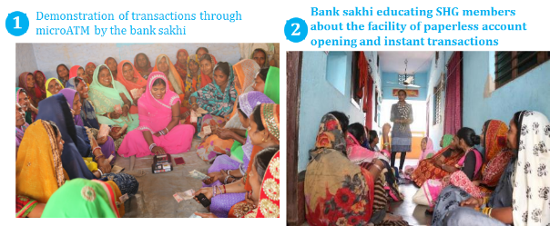

|  |  |  |
| --- | --- | --- |
| Session 9 - 8 | Prepared by BASIX Consulting and Technology Services Ltd | 105 |

**Session 9 - 9: Brands**

Name some famous brand and why are you able to recall them?

|  |  |  |
| --- | --- | --- |
| Session 9 - 9 | Prepared by BASIX Consulting and Technology Services Ltd | 106 |

**Session 9 - 10: Branding Essentials**

These three parameters helps in making any brand strong and memorable for customers. For example brands such as Sudha Dairy

|  |  |  |
| --- | --- | --- |
| Session 9 - 10 | Prepared by BASIX Consulting and Technology Services Ltd | 107 |

**Session 9 - 11: Why is Branding of CSP Outlet Important?**

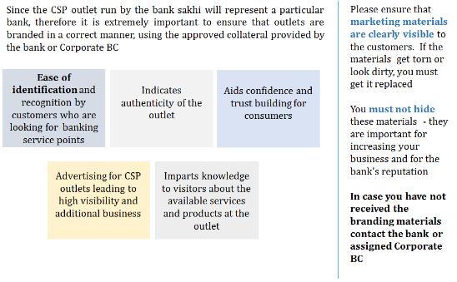

|  |  |  |
| --- | --- | --- |
| Session 9 - 11 | Prepared by BASIX Consulting and Technology Services Ltd | 108 |

**Session 9 - 12: Examples of Branding by Bank Sakhis**

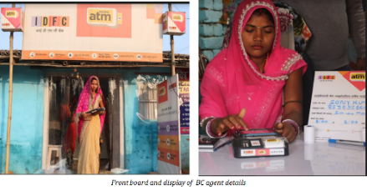

|  |  |  |
| --- | --- | --- |
| Session 9 - 12 | Prepared by BASIX Consulting and Technology Services Ltd | 109 |

**Session 9 - 13: Examples of Branding by Bank Sakhis**

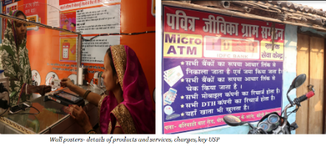

|  |  |  |
| --- | --- | --- |
| Session 9 - 13 | Prepared by BASIX Consulting and Technology Services Ltd | 110 |

**Session 9 - 14: Examples of Branding by Bank Sakhis**

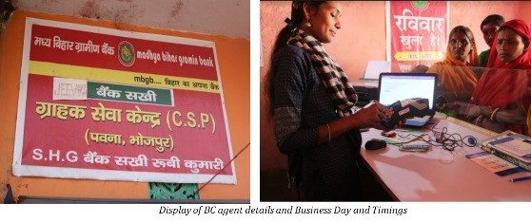

|  |  |  |
| --- | --- | --- |
| Session 9 - 14 | Prepared by BASIX Consulting and Technology Services Ltd | 111 |

**Session 9 - 15: From the pictures shown in the last 3 slides, what do you think are the key branding requirements for CSP outlet?**

|  |  |  |
| --- | --- | --- |
| Session 9 - 15 | Prepared by BASIX Consulting and Technology Services Ltd | 112 |

**Session 9 - 16: Specific Branding Requirements at CSP Outlet**

**Mandatory Information and Contact Details**

* Name of the Bank Sakhi
* Business days and timings
* Bank Sakhi contact details
* Name of Banks’ Contact Person
* Customer care number / Any other Bank contact details

**Certificates**

* Business Correspondent Certificate (if provided by the bank)

**Signage**

* Front board
* Wall posters- products and services, prices, key USP messages such as CSP counter also opened on Sunday

|  |  |  |
| --- | --- | --- |
| Session 9 - 16 | Prepared by BASIX Consulting and Technology Services Ltd | 113 |

**Session 9 - 17: Customer Service**

1. What is customer service?
2. Why is it important?

|  |  |  |
| --- | --- | --- |
| Session 9 - 17 | Prepared by BASIX Consulting and Technology Services Ltd | 114 |

**Session 9 - 18: What is Customer Service?**

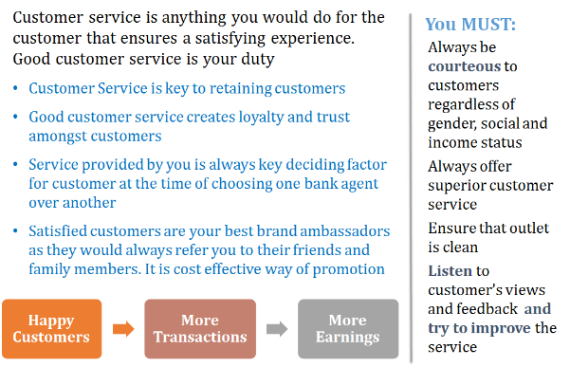

|  |  |  |
| --- | --- | --- |
| Session 9 - 18 | Prepared by BASIX Consulting and Technology Services Ltd | 115 |

**Session 9 - 19: Components of Customer Service**

|  |  |  |
| --- | --- | --- |
| **Stages of customer interaction** | **Expectation of customer** | **Required elements for customer service** |
| Product Promotion | * Understand product value proposition * Understand product features | * You should be able to explain the basic product features and benefits for customers * Do not mis-sell product or overpromise to customers |
| Product Sale | * Avail product features as listed * Receive benefits/promises made at the time of promotion * On time service | * Inform customers of all product features including TAT, charges, and so on * Under promise and over deliver |
| Post Sale Service | * Resolve out any issues without stress * Receive quick and timely service | * Try and go extra mile to resolve customers grievances * Keep in touch with customers and update about complaint status regularly |

|  |  |  |
| --- | --- | --- |
| Session 9 - 19 | Prepared by BASIX Consulting and Technology Services Ltd | 116 |

**Session 9 - 20: What is Customer Service?**

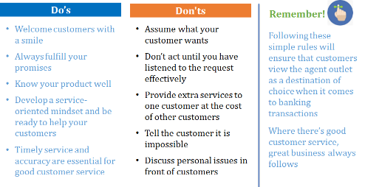

|  |  |  |
| --- | --- | --- |
| Session 9 - 20 | Prepared by BASIX Consulting and Technology Services Ltd | 117 |

**Session 9 - 21: Roleplay**

* Now one of the participants will have to act as a trainer and teach rest of the class how to provide effective customer service
* The participant acting as trainer can refer to the three slides just preceding this one.

|  |  |  |
| --- | --- | --- |
| Session 9 - 21 | Prepared by BASIX Consulting and Technology Services Ltd | 118 |

**Session 9 - 22: Grievance Redressal Process - MBGB Bank**

Bank Sakhis must understand that they are MBGB Bank’s representatives on the ground; they are the customer’s primary contact point for any concern or issues. It is critical, for a bank sakhi, to guide or support customers to get their complaints resolved in a timely and professional manner.

**There are 4 ways for customers to register their complaints**

1. In person: Customer can obtain the complaint form from the branch manager/bank’s website www.mbgbpatna.com , submit it to the branch manager and obtain acknowledgement.
2. By telephone: Complaints can also be lodged at Bank’s Call Centre on toll free number 18001807777 accessible from MTNL/BSNL fixed phones/Mobile throughout India or 0612 -2385418
3. By mail/post: Complaints can be mailed to the Principal Nodal Officer at this address.

The Principal Nodal Officer Madhya Bihar Gramin Bank HO: Shri Vishnu Commercial Complex, Asochak, Near Highway Petrol Pump, NH-30 Patna-800016, Bihar Contact No. : 0612-2385405

1. By e-mail/internet: [complaints@mbgbpatna.com](mailto:complaints@mbgbpatna.com)

**Escalation**

YOU must ensure that you understand the escalation matrix for various issues and communicate the same to the customer

|  |  |  |
| --- | --- | --- |
| Session 9 - 22 | Prepared by BASIX Consulting and Technology Services Ltd | 119 |

**Session 9 - 23: Grievance Management for Agents - MBGB Bank**

* You should contact your District Coordinator of CDOT in case of any technical issues. If there is no response or your issue is not resolved to the satisfaction within 2 days then you may contact Financial Inclusion Team of CDOT @ 7546900389
* In case of any banking transactions related issues you may also reach out to MBGB’s FI Manager at RO office.

|  |  |  |
| --- | --- | --- |
| Session 9 - 23 | Prepared by BASIX Consulting and Technology Services Ltd | 120 |

**Session 9 - 24: How to Handle Difficult Customers?**

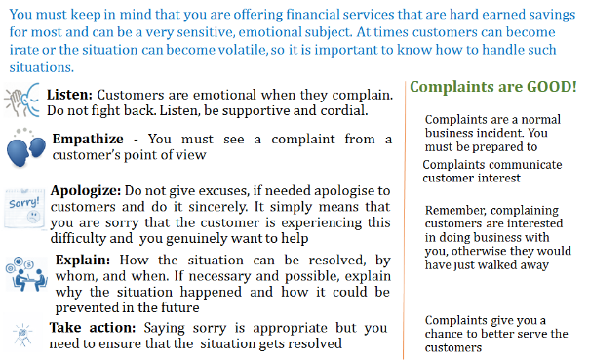

|  |  |  |
| --- | --- | --- |
| Session 9 - 24 | Prepared by BASIX Consulting and Technology Services Ltd | 121 |

**Session 9 - 25: Roleplay**

**How do you handle a difficult customer?**

One of the participant act as bank sakhi and another participant act as a difficult customer. The customer is angry because money is deducted from her account but the transaction is showing failed. So she is fighting with bank sakhi to give her money.

|  |  |  |
| --- | --- | --- |
| Session 9 - 25 | Prepared by BASIX Consulting and Technology Services Ltd | 122 |

**Session 9 - 26: Why bank sakhi should take efforts to educate customers?**

|  |  |  |
| --- | --- | --- |
| Session 9 - 26 | Prepared by BASIX Consulting and Technology Services Ltd | 123 |

**Session 9 - 27: Why educate customers?**

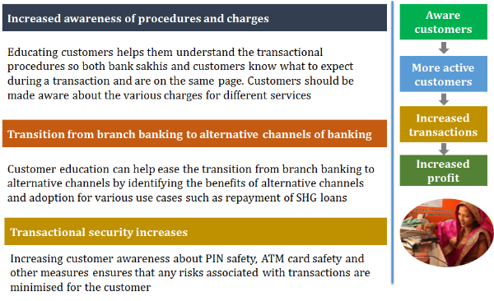

|  |  |  |
| --- | --- | --- |
| Session 9 - 27 | Prepared by BASIX Consulting and Technology Services Ltd | 124 |

**Session 9 - 28: Recap**

* Know your product
* Understand your customer
* Network with respected and reputed people/institutions in the village
* Ensure all branding material is in place
* Respect your customers. Customer service quality is essential for the success of your business
* Educate your customers

**Success of the business depends completely upon how you perform!!  
and  
How satisfied your customers are!!**

|  |  |  |
| --- | --- | --- |
| Session 9 - 28 | Prepared by BASIX Consulting and Technology Services Ltd | 125 |

## Facilitation Notes

1. Discuss with the participants, the value proposition for customers for transacting through bank sakhis using **c**
2. Explain the concept of customer pitch and how to develop one by using **Slide - Session 9 - 3** and **Slide - Session 9 - 4**
3. Divide the participants in 4 groups. Make chits of different customer segments:
   1. Students
   2. Women- House wives
   3. Daily wage earners
   4. Salaried employees
   5. Farmers
   6. Old aged people
4. Ask one member of each group to pick one chit. The groups will have to develop their pitch for the customer segment in the chit picked by their members. Give 15 minutes to develop their pitch where they must convince the customer from the chosen segment to open bank account or make cash deposit through bank sakhi.
5. Once the groups are ready with their pitch, trainer will have to choose any one of the groups randomly. One of the members of the chosen group will act as bank sakhi and convince the trainer who will enact the role of customer segment chosen by the selected group.
6. Give 10 minutes for role pay. After the role play, discuss in plenary, what did the participant who enacted as bank sakhi did best and what could have been improved. Spend around 15 minutes for discussion.
7. Wrap up the session on customer pitch with **Slide - Session 9 - 6**, by telling the participants what to do after delivering the good pitch.
8. Discuss in plenary with the participant what all marketing activities they can do to market their bank work. Use **Slide - Session 9 - 7** and **Slide - Session 9 - 8**. Remind them that the bank sakhi are extended arm of bank for marketing
9. Ask the participants to name some of the brands that they can recall. Once the participants have given 4-5 famous brands which they are able to recall, ask them why they are able to remember these brands so well? Guide the discussion towards major branding essentials on **Slide - Session 9 - 10**:
   1. Staff behavior
   2. Outlet look
   3. Standard across outlets
10. Discuss in plenary with the participants why branding of CSP outlet is essential?   
    Use **Slide - Session 9 - 11**
11. Show them examples of branding of CSP counters of existing bank sakhis on **Slides** **from** **Session 9 - 12 to Session 9 - 14**
12. Ask the participants to refer to the last 3 slides just shown and tell what are the branding requirements for CSP outlet? Show them the last 3 slides again. Show **Slide - Session 9 - 16**, after the participants have given out the branding requirements for CSP outlet.
13. Wrap this sub- session on Marketing and Branding and proceed to next sub-session of Customer Service. Mention to the participants that Customer Service is also one of the essential ingredient of branding.
14. Ask the participants what they understand from Customer Service and why they think it’s important
15. Explain the participants what customer service is and why it is important for bank sakhi work using **Slide - Session 9 - 18**
16. Using **Slide - Session 9 - 19** explain the participants, to provide good customer service, bank should understand customers’ expectations and accordingly provide service. To provide good customer service bank sakhi should:
    1. **Empathy, patience and consistency-** Some customers will be irate; others will be full of queries / questions; some will just be chatty. Agents must know how to handle all of them and provide the same level of service every time.
    2. **Adaptability-** Every customer is different, and some may even seem to change week-to-week. Agents should be able to handle surprises, sense the customer’s mood and adapt accordingly.
    3. **Clear communication-** Agents must ensure they convey to customers exactly what they mean. Agents must use positive language, try to stay cheerful and never end a conversation without confirming that the customer is satisfied.
    4. **Service breadth-** Customers appreciate an agent who will see their problem through to its resolution. Handling one customer while others are waiting.
    5. **Knowledge**- Ultimately customers rely on agents for their knowledge of your product. The agents thus have to stay informed enough to respond to most inquiries and know where to keep short if the questions become too detailed or technical for them to answer.
17. Using **Slide - Session 9 - 20**, explain the participants what they should do and what they should not do to provide good customer service
18. Conduct roleplay to get the concepts of customer service revised for the participants. Ask participants to volunteer for roleplay. The volunteer will have to act as Trainer and teach the class about customer service and rest of the participants must participate and ask questions. Give Volunteer 10 mins. To go through customer service slides and prepare her session. 20 mins. For teaching the class. (Total 30 mins. For the activity)
19. Explain to the participants the various options of grievance redressal available for them and their customers. Use **Slides from Session 9 - 22 to Session 9 - 25**. Distribute the Handout 9.1 Grievance Redressal Mechanism to the participants. Give them 5 minutes to go through the handout and ask them if they have queries or doubts.
20. Discuss in plenary, how the bank sakhis should handle difficult or angry customers.   
    Use **Slide - Session 9 - 26** for discussion
21. Choose two volunteers for role play. One of the volunteer will act as bank sakhi and the other volunteer will act as angry customer whose money got deducted from her bank account but bank sakhi got the message of transaction failure. So the customer is fighting with her to give her money. Now bank sakhi must deal with this customer. Give volunteers 10 mins for preparation of role play, 20 mins. For roleplay and 10 mins. For discussion in plenary about whether bank sakhi could manage the situation well or not and what else could have been done.
22. Ask the participants why they should educate their customers. Explain in detail the advantages of educating customers using **Slide - Session 9 - 27**
23. Conduct recap of the key highlights of the session by using **Slide - Session 9 - 28.**
24. Close the session and continue towards review and closure of the training.

# Session 10: Review and Closure

|  |  |  |
| --- | --- | --- |
| Overview |  | This session provides closure to the bank sakhi training workshop. Participants review the main messages of the course and post training test of bank sakhis conducted. |
| Session Objectives |  | By the end of this session participants will be able to:   * List major learning points of the training workshop * Evaluate the learning ability of bank sakhis |
| Duration |  | 105 min |
| Methodology and Steps |  | **Group Exercise and Individual test**  Step 1: Main Message Review (60 minutes)  Activities: Group Exercise  Resources: Flipcharts and markers  Step 2: Post Training Test of Bank Sakhis (45 minutes)  Activities: Individual Evaluation  Resources: Test papers. |
| Resources |  | Test sheets  Flipcharts and markers |
| Trainers’ Preparation |  | Trainers should do the following before starting the session:   * Organize all the materials needed for the session (Test sheets markers, Flip Chart paper) |

## Facilitation Notes

1. (30 minutes) Tape 9 blank flipcharts on the walls of the training room. Each chart should be titled with a main Session of the workshop. Divide the participants into 9 groups and assign each group one flipchart and one session to list their most important learnings of that session
2. (30 minutes) In plenary, each group present their flip chart with most important learnings.
3. After recap exercise, distribute post training test sheets to all the participants. Give 45 minutes to complete the test.
4. Close the training with closing remarks.